**PROJECT REPORT**

**PROPERTY MANAGEMENT APPLICATION**

**USING SALESFORCE**

**Introduction:**

**OVERVIEW: Property management is the operation, control, maintenance, and**

**oversight of**[**real estate**](https://en.wikipedia.org/wiki/Real_estate)**and physical property. This can include residential, commercial, and land**

**real estate. Management indicates the need for real estate to be cared for and monitored, with**

**accountability for and attention to its useful life and condition. This is much akin to the role**

**of**[**management**](https://en.wikipedia.org/wiki/Management)**in any**[**business**](https://en.wikipedia.org/wiki/Business)**.**

**Property management is the management of personal property, equipment, tooling, and physical**

**capital assets acquired and used to build, repair, and maintain end item deliverables. Property**

**management involves the processes,**[**systems**](https://en.wikipedia.org/wiki/Property_management_system)**, and workforce required to manage the**[**life cycle**](https://en.wikipedia.org/wiki/Property_Cycle)**of**

**all acquired property as defined above, including acquisition, control, accountability**

**responsibility, maintenance, utilization, and disposition.**

**Under the, property management service are to be prescribed under seven specified**

**categories as follows:**

1. **General management services relating to a property;**

**2. Management of the environment of a property;**

**3. Repair, maintenance and improvement of a property;**

**4. Finance and asset management relatives**

**5. Facility management relating to a property;**

**6. Human resources management relating to personnel involved in the management property; and**

**7. Legal services relating to the management of a property**

**PURPOSE:** **One of the most important aspects of property management is maintaining good**

**relationships with residents and owners. Property management companies will effectively**

**communicate with their residents to resolve any issues that may arise as well as build relationships**

**with the owners.**

**PROBLEM DEFINITION & DESIGN THINKING:**

**EMPATHY MAP:**

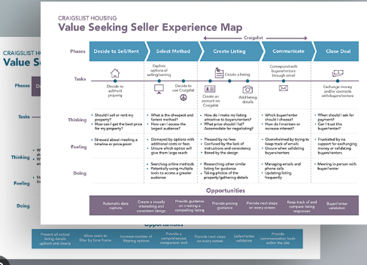

**IDEATION AND BRAINSTORMING MAP:** 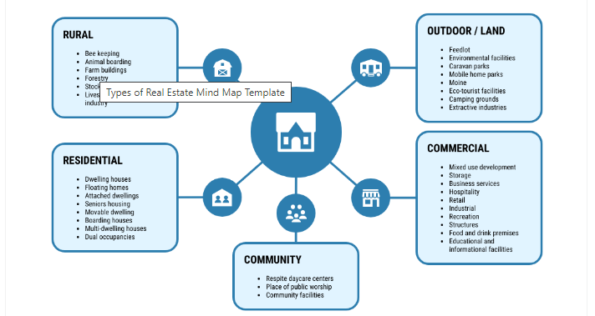

RESULTS:

|  |  |  |  |
| --- | --- | --- | --- |
| DATA MODEL |  |  |  |
|  |  |  |  |
|  |  |  |  |
|  |  |  |  |
|  |  |  |  |
|  |  |  |  |
|  |  |  |  |
|  |  |  |  |

**Activity**

**1: Creating Developer Account Creating a developer org in salesforce.**

**1. Go to developers.salesforce.com/**

**2. Click on sign up.**

**3. On the sign up form,**

**enter the following details :**

**a. First name & Last name**

**b. Email c. Role : Developer**

**d. Company : College Name**

**e. County : India**

**f. Postal Code: pin code**

**g. Username :should be a combination of your name and company This need not be an actual email id,**

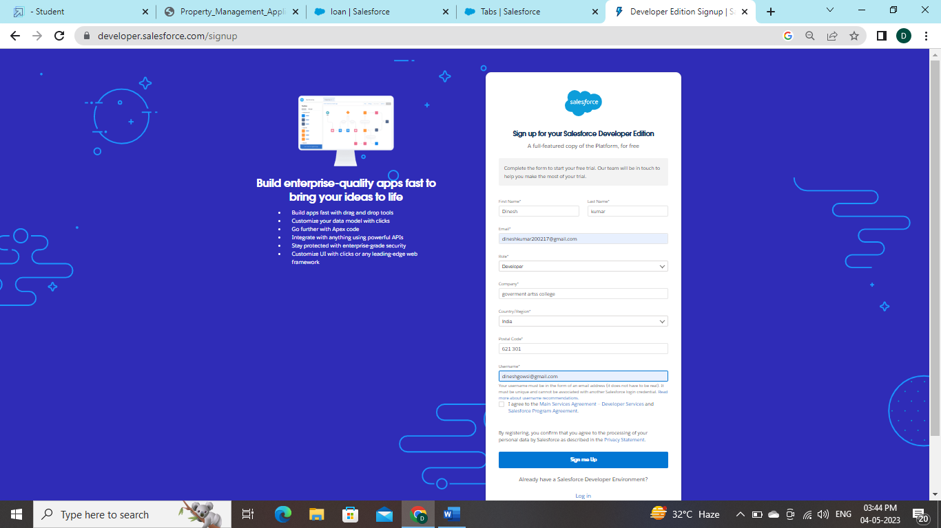

**Activity 2-**

**Account Activation**

**1. Go to the inbox of the email that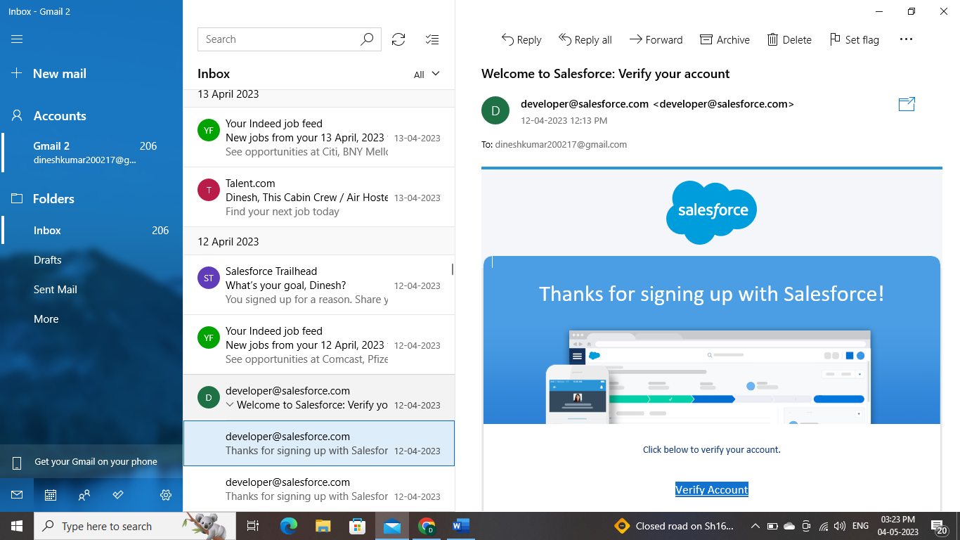 you used while signing up. Click on the verify account to activate your account. The email may take 5-10mins, as**

**Activity1:**

**Objects To Navigate to Setup page**

**: 1. Click on gear icon → click setup.**

**create an object:**

1. **From the setup page → Click on Object Manager → Click on Create → Click on Custom Object.**
2. **On Custom object defining page:**
3. **3. Enter the label name, plural label name, click on Allow reports, Allow search → Save**

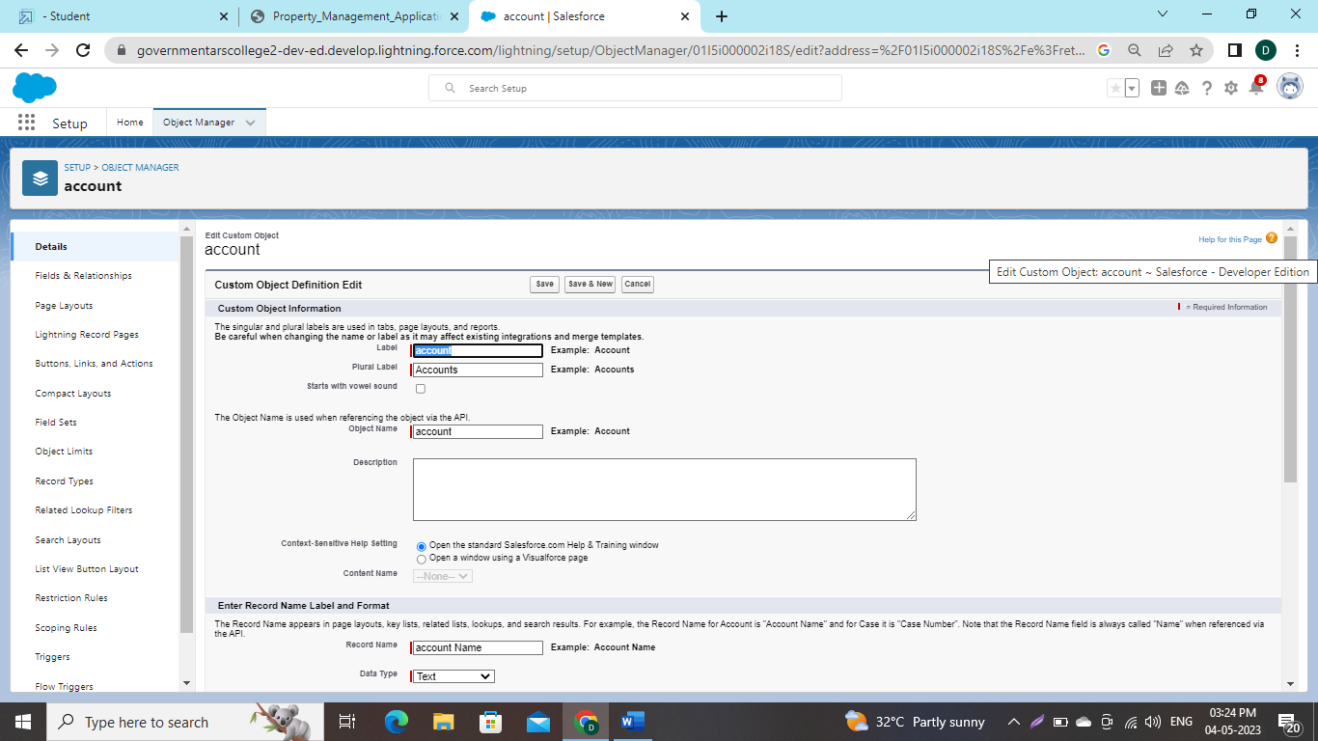

**Activity2:**

**Create Object Buy**

**1. To create an object:**

**2. From the setup page → Click on Object Manager → Click on Create → Click on Custom Object.**

**3. Enter the label name→Buy**

**4. plural label name→ Buyers**

**5. click on Allow reports,**

**6. Allow search → Save**

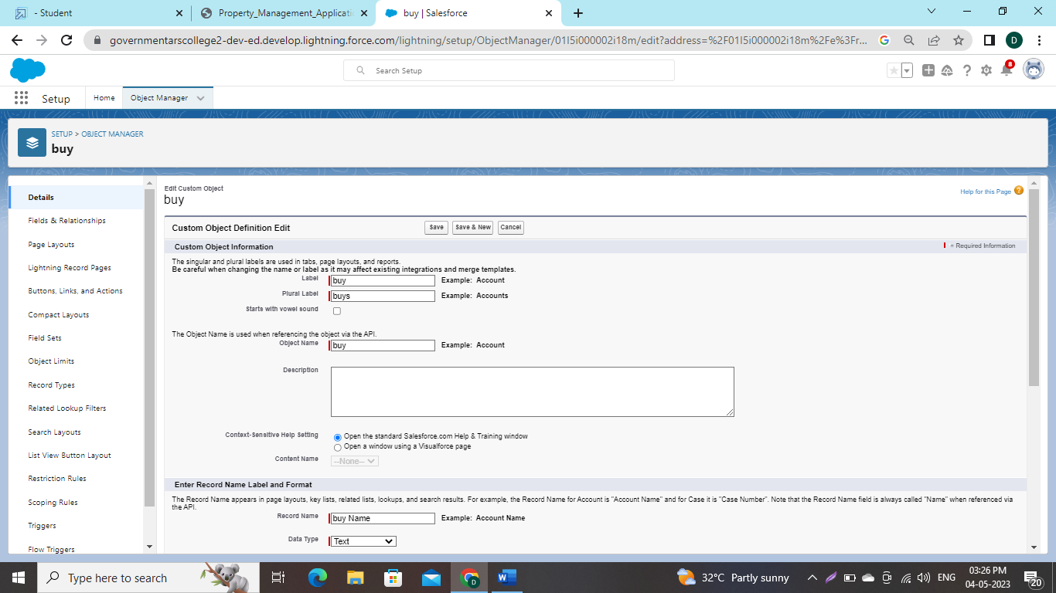**Activity3:**

**Create Object Rent**

**1. To create an object:**

**2. From the setup page → Click on Object Manager → Click on Create → Click on Custom Object.**

**3. Enter the label name→Rent**

**4. plural label name→ Rents**

**5. click on Allow reports**

**, 6. Allow search → Save**

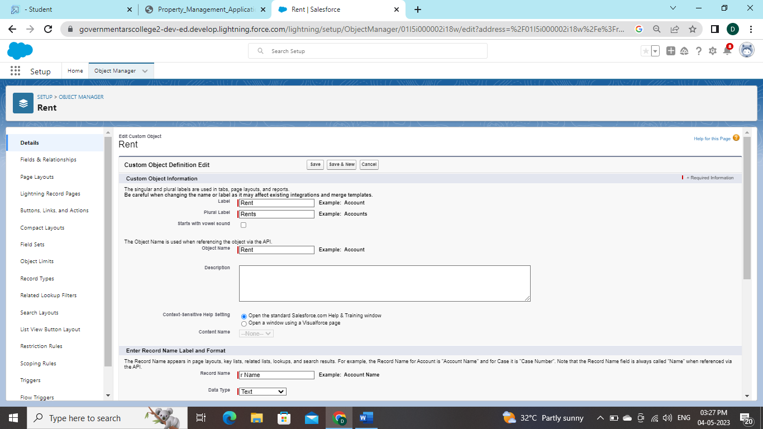

**Activity3:**

**Create Object Loan**

**7. To create an object:**

**8. From the setup page → Click on Object Manager → Click on Create → Click on Custom Object.**

**9. Enter the label name→Loan**

**10. plural label name→ Loans**

**11. click on Allow reports,**

**12.Allow search → Save**

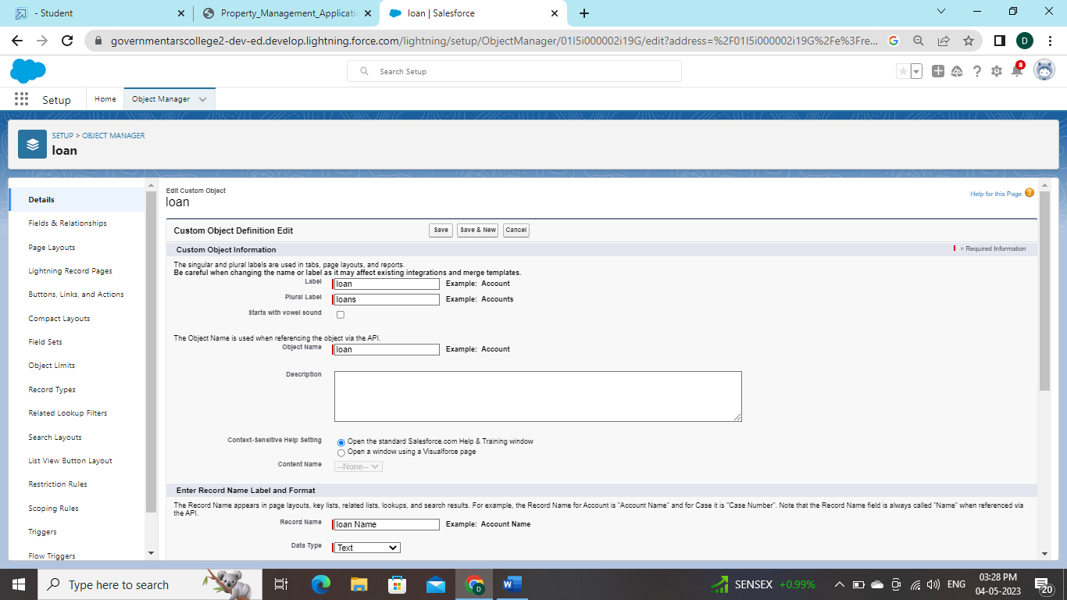

**Activity 1**

**: Create the Lightning Tab To create a Tab:(Lead)**

1. **Go to setup page → type Tabs in Quick Find bar → click on tabs → New (under custom object tab)**
2. Select **Object(Lead) → Select the tab style → Next (Add to profiles page) keep it as default → Next (Add to Custom App) keep it as default → Save.**

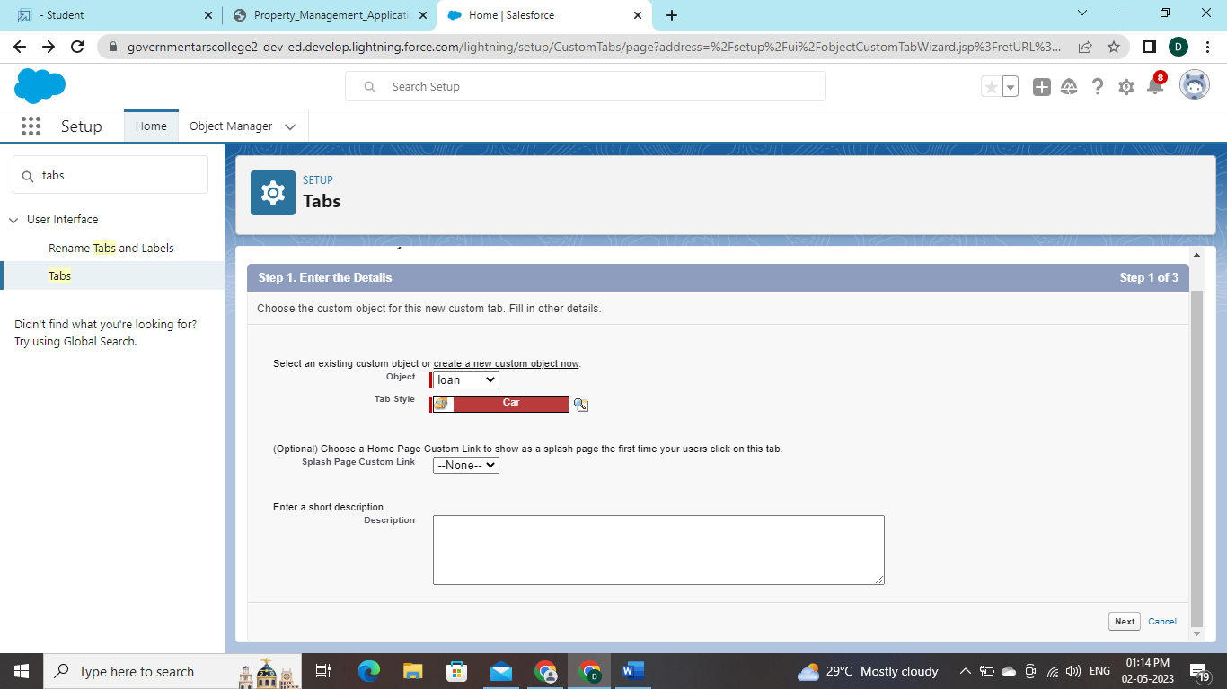

**Activity 2:**

**To create a Tab:(Buy)**

1. **Go to setup page → type Tabs in Quick Find bar → click on tabs → New (under custom object tab)**
2. **2. Select Object(Buy) → Select the tab style → Next (Add to profiles page) keep it as default → Next (Add to**
3. **Custom App) keep it as default → Save.**

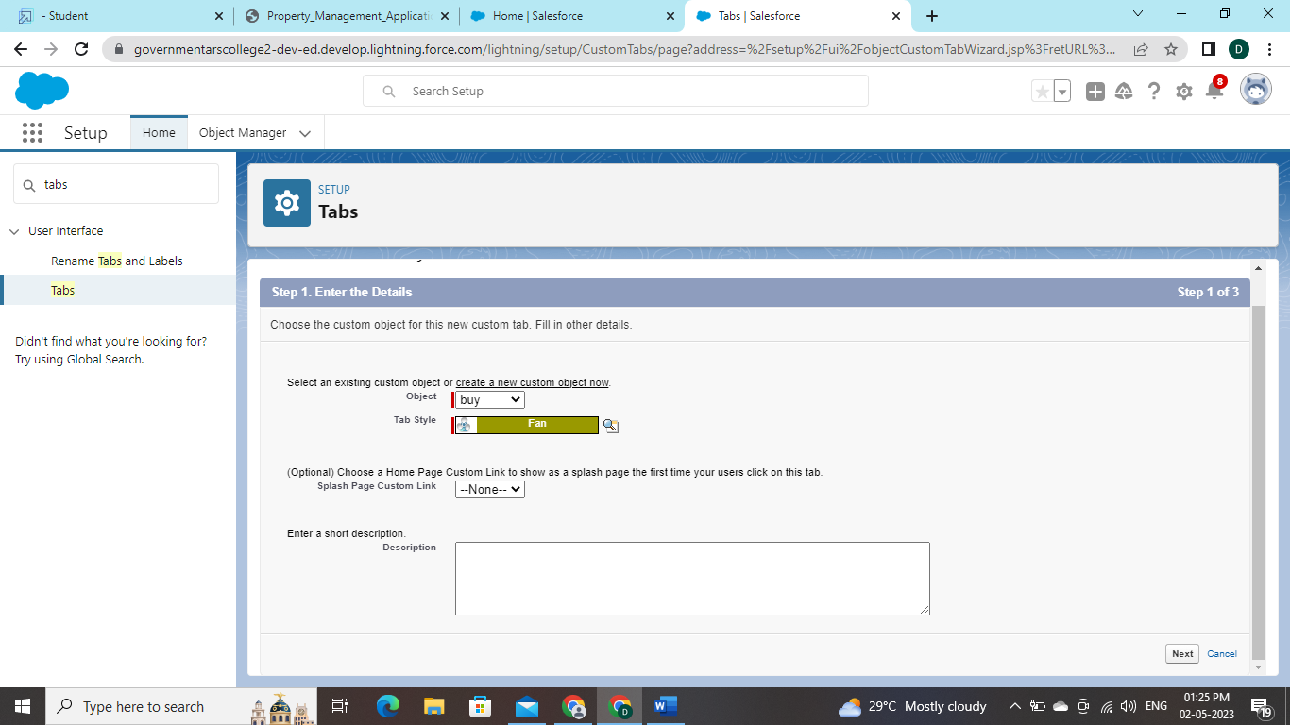

Activity **3**

**To create a Tab:(Rent)**

1. **Go to setup page → type Tabs in Quick Find bar → click on tabs → New (under custom object tab)**

**2. Select Object(Rent) → Select the tab style → Next (Add to profiles page) keep it as default → Next (Add to Custom App) keep it as default → Save**

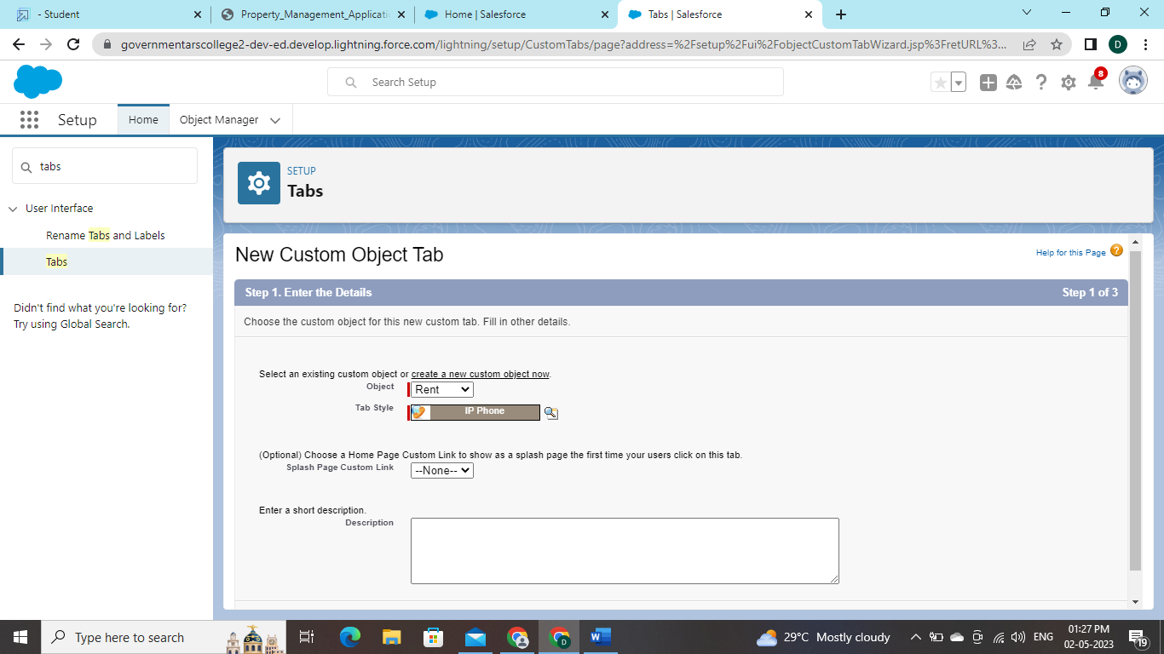

**Activity4:** 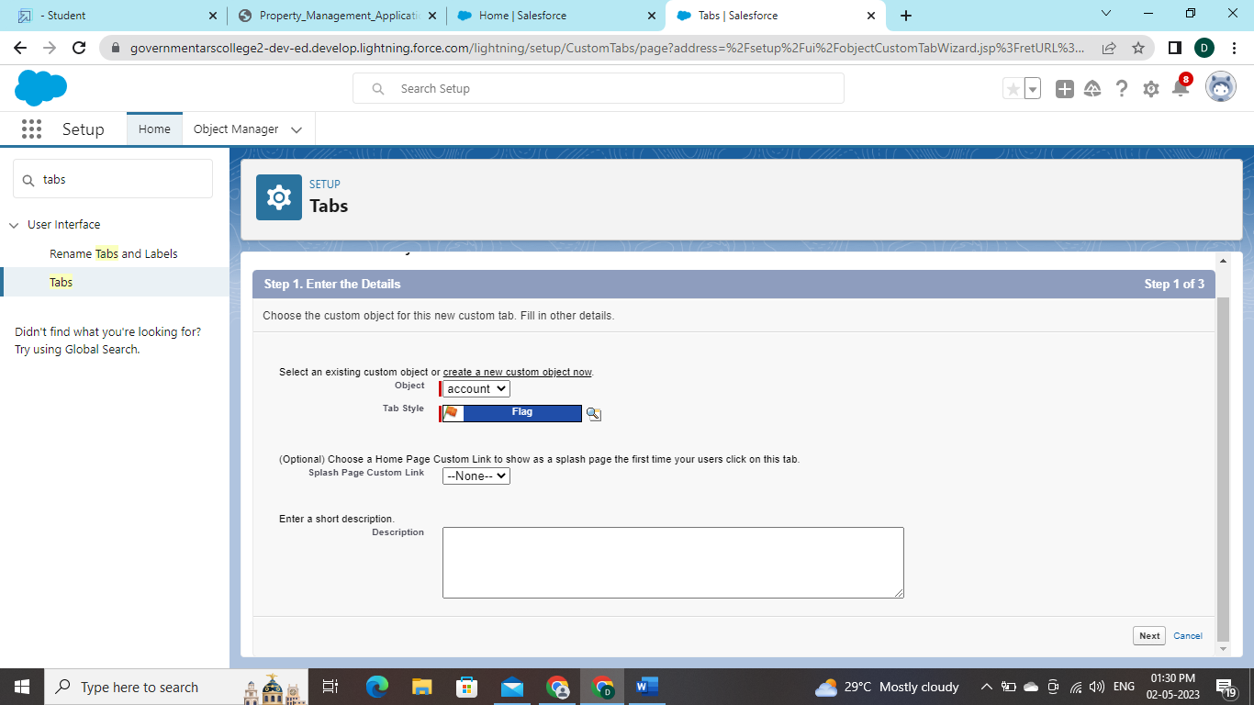

**To create a Tab:(Loan)**

1. **Go to setup page → type Tabs in Quick Find bar → click on tabs → New (under custom object tab)**

**2. Select Object(Buy) → Select the tab style → Next (Add to profiles page) keep it as default → Next (Add to Custom App) keep it as default → Sav**

**Activity1:**

**Create the Lightning App**

**1. Go to setup page → search “app manager” in quick find → select “app manager” → click on New lightning App.**

**2. Fill the app name as an Property Management in app details and branding →Next → (App option page) keep it as default → Next**

**3. (Utility Items) keep it as default → Next → (Add Navigation Items)(add tabs Lead, Buy, Rent, Loan) → Next → (Add User Profile) Add System Administrator, Salesforce platform user, Standard User → Next**.

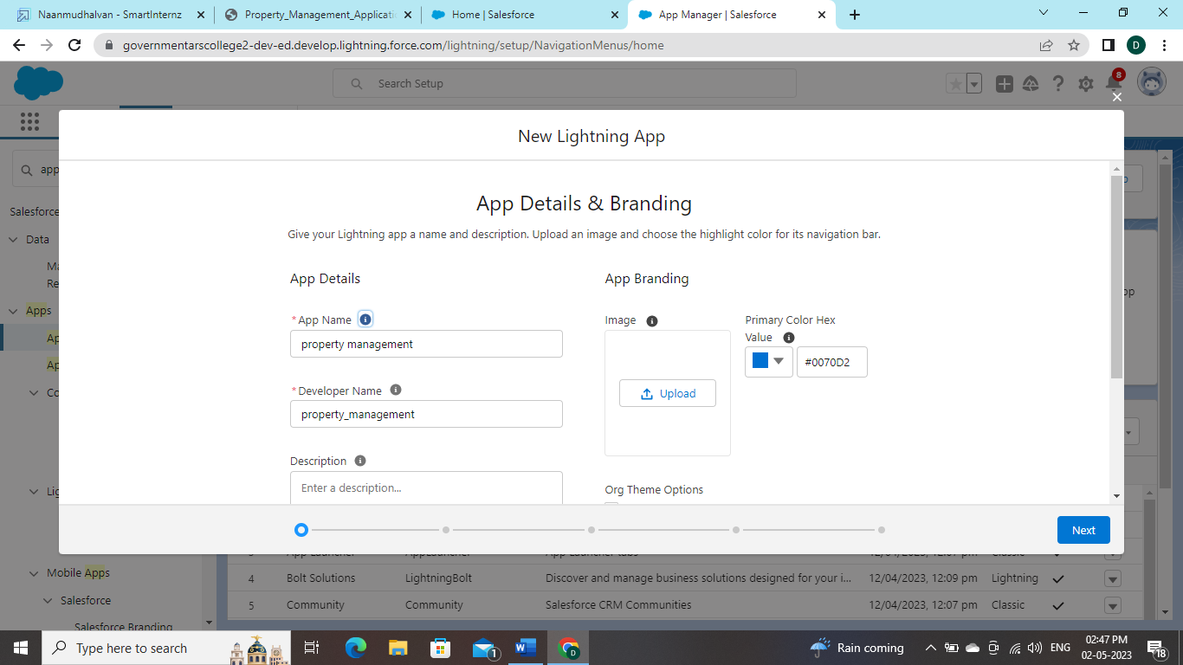

To **Add Navigation Items: Select the items from the search bar and move it using the arrow button → Next**

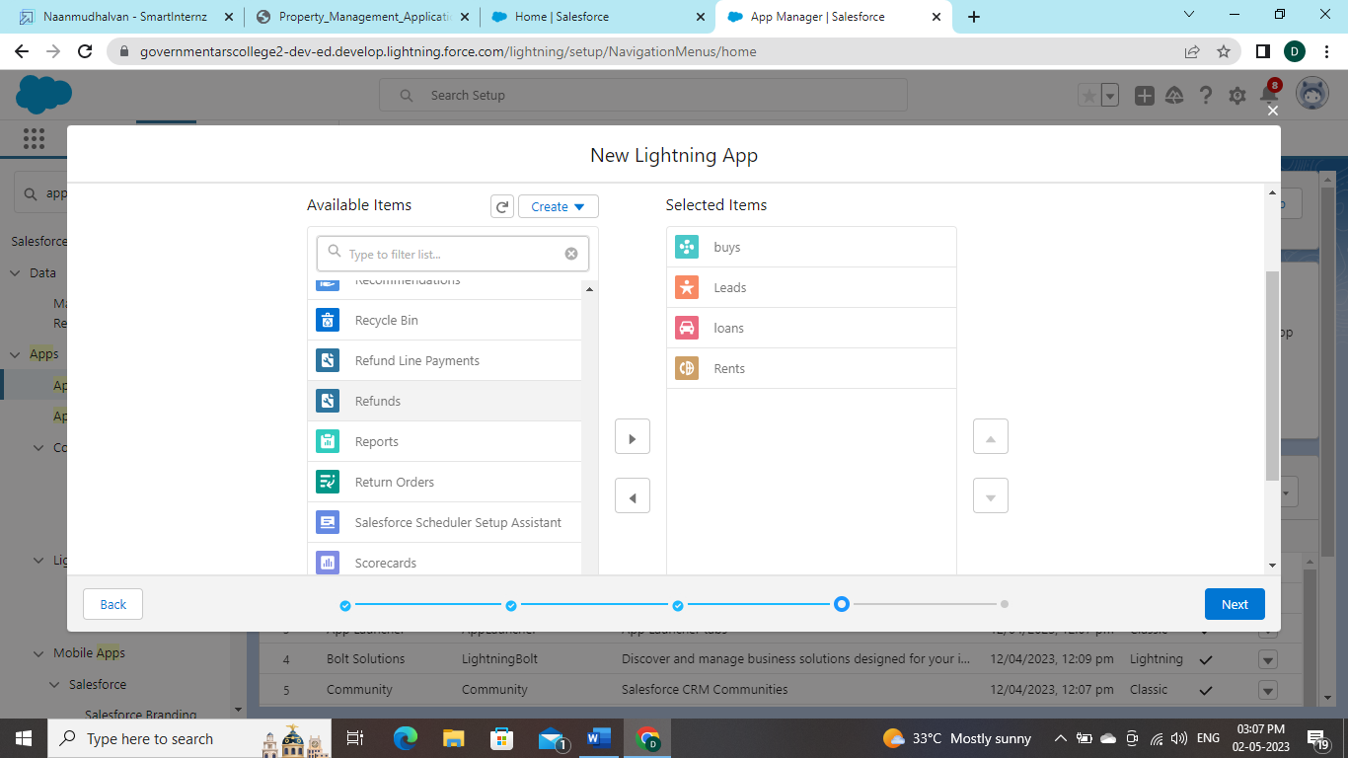

**5. To Add User Profiles: Search profiles in search bar → click on the arrow button → save & finish**

**Activity:**

**Create the Lead Field 1. Go to setup → click on Object Manager → type object name in search bar → click on the object**

**2. Now click on “Fields & Relationships ” → New**.

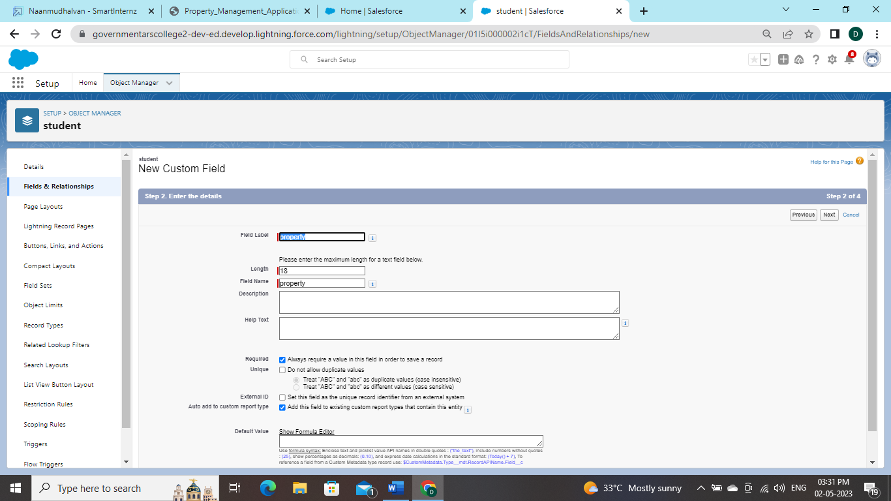

**Create the remaining Fields:**

**Follow the Above Steps to create the Field just change the Labels for Below**

**Fields Lead:(AutoNumber Created Field while creating Object) →L-{0000}**

**State: Create the Picklist Field (Maharashtra, Gujarat, Rajasthan)(Field Dependency)**

**City: Create the Picklist(Mumbai, Pune, Nashik)(Field Dependency)**

**Email: Create the Email Select the Data Type As Email (Email)**

**Phone: Select the Field Data type as (Phone**)

**Activity2:**

**For Object Buy**

**1. Create Field for Buy**

**2. Create Property Type: (Picklist) (Residential, Commercial, Industrial)**

**3. Discount:(Percentage As the Field Data Type)**

**4. State:Create the Picklist Field (Maharashtra, Gujarat, Rajasthan)(Field Dependence**

**5. City:(Take Any City for Field Dependency)**

**6. Annual Amount To Be Paid**

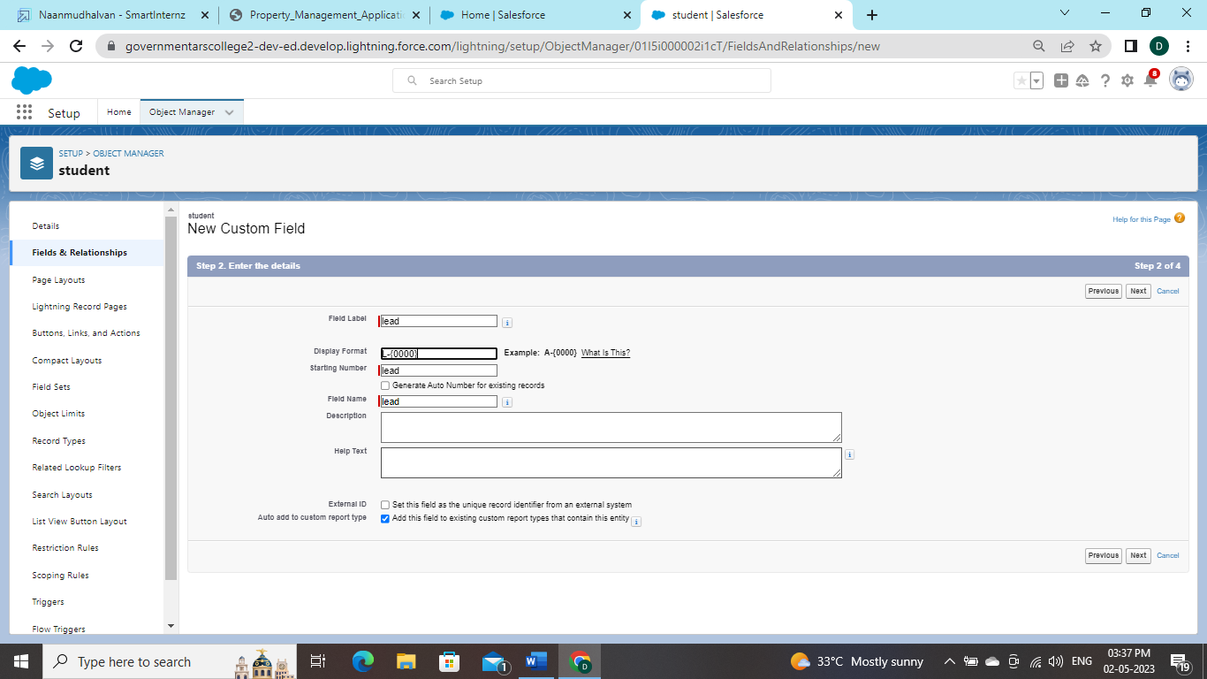

Ac**tivity3**

**: Create Field for Rent**

**1. Rent:(Auto Number while Creating the object)→ R-{0000}**

**2. Rental City:Select the Text as the Field Data Name(Any City)**

**3. BHK type:(Picklist) (1BHK, 2BHK,3BHK)**

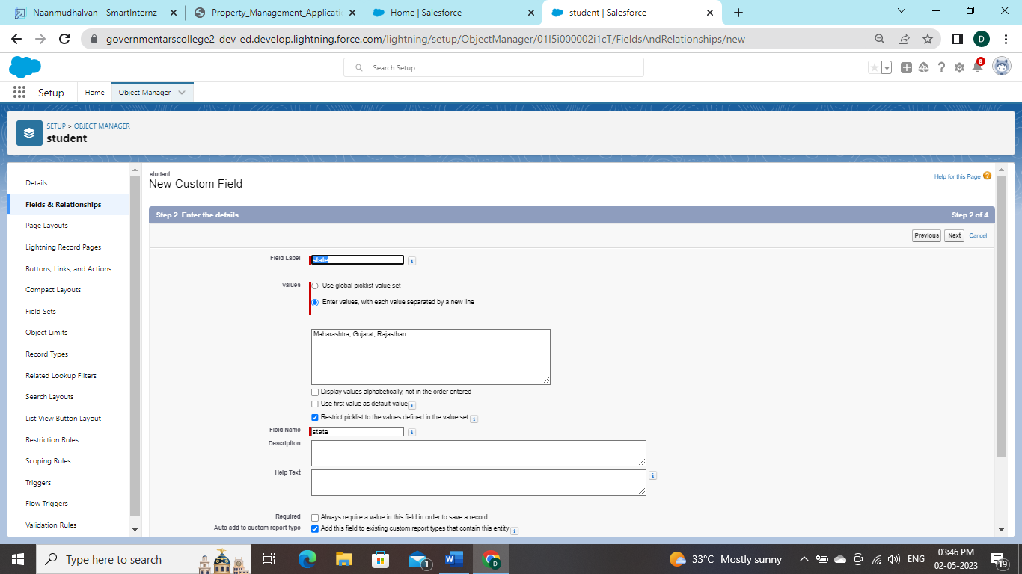

**Activity3: Create Field for Rent**

**1. Rent:(Auto Number while Creating the object)→ R-{0000}**

**2. Rental City:Select the Text as the Field Data Name(Any City)**

**3. BHK type:(Picklist) (1BHK, 2BHK,3BHK**

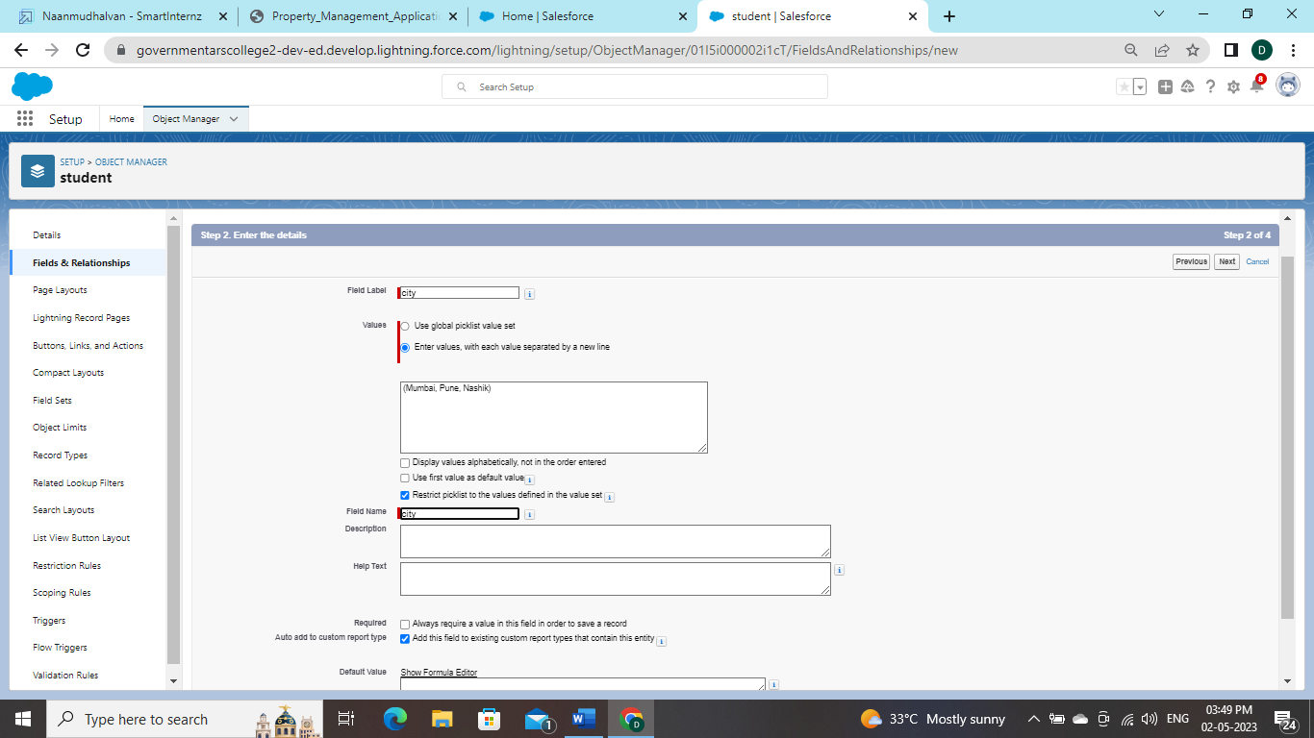

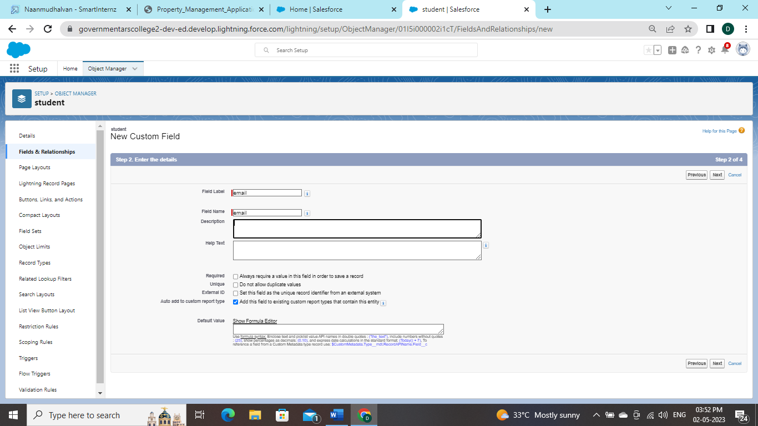

**1. Loan Id: Auto generated Field Take it as Auto number LN-{0000**

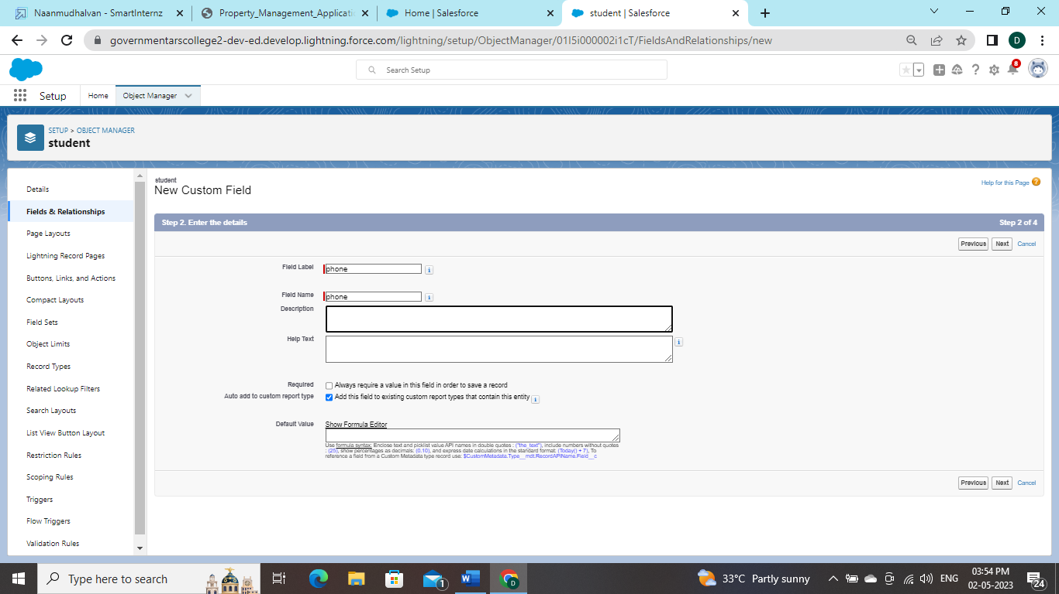

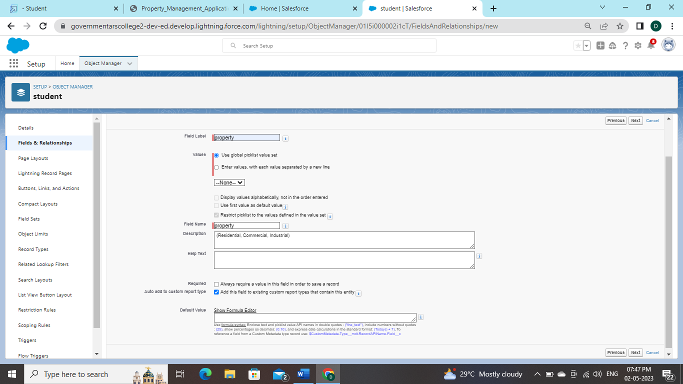

**2. Interest Rate: (Select the Field Data Type As Currency)**

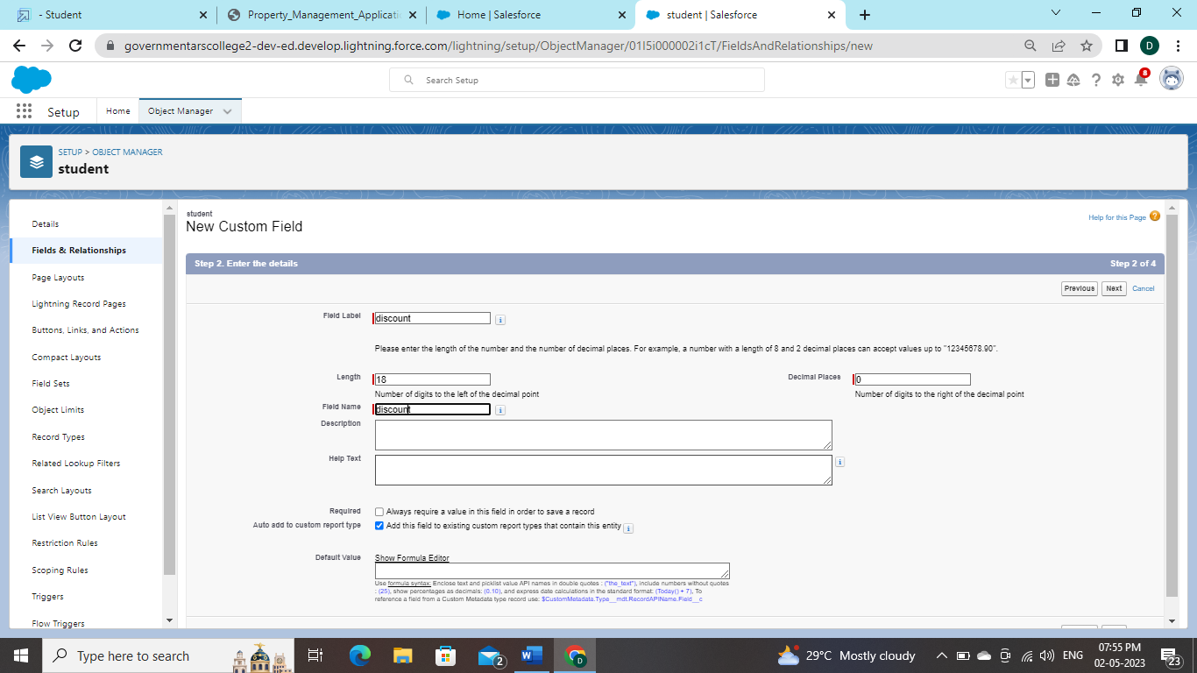

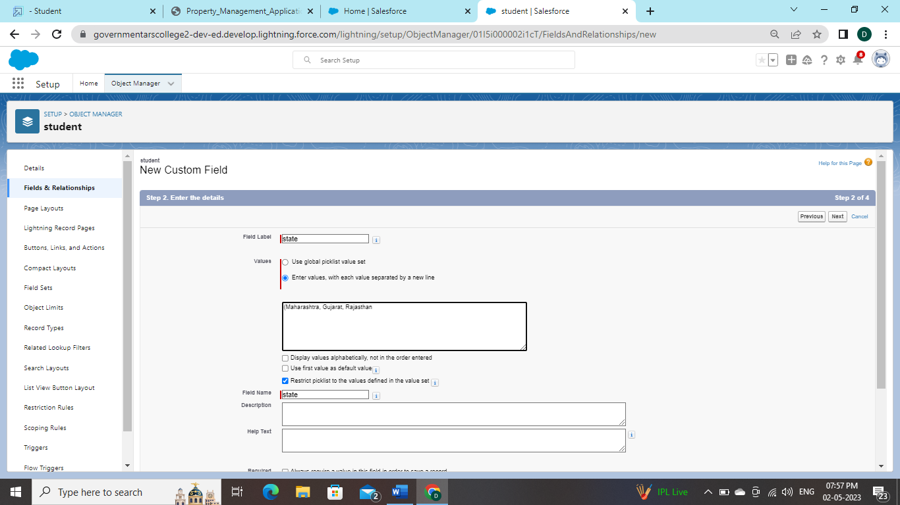

**3.Term:(Select the Field Data type as Number**)

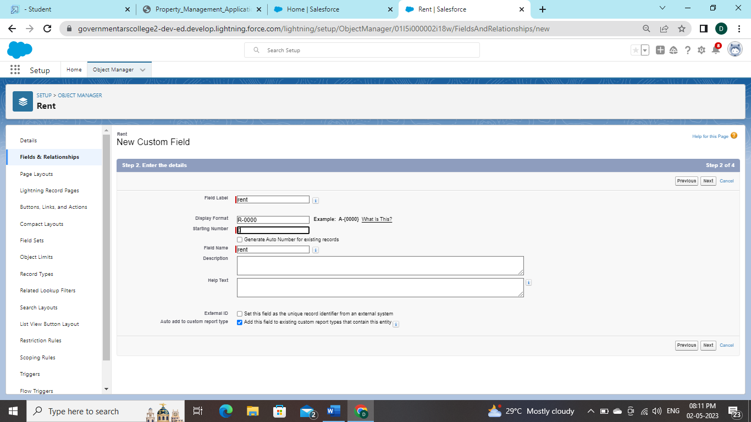

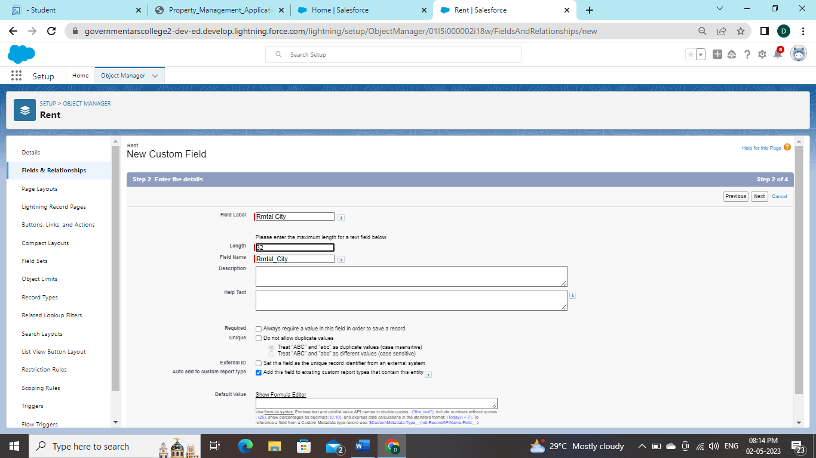

**4. Annual Loan Field create the Number as the field data type**

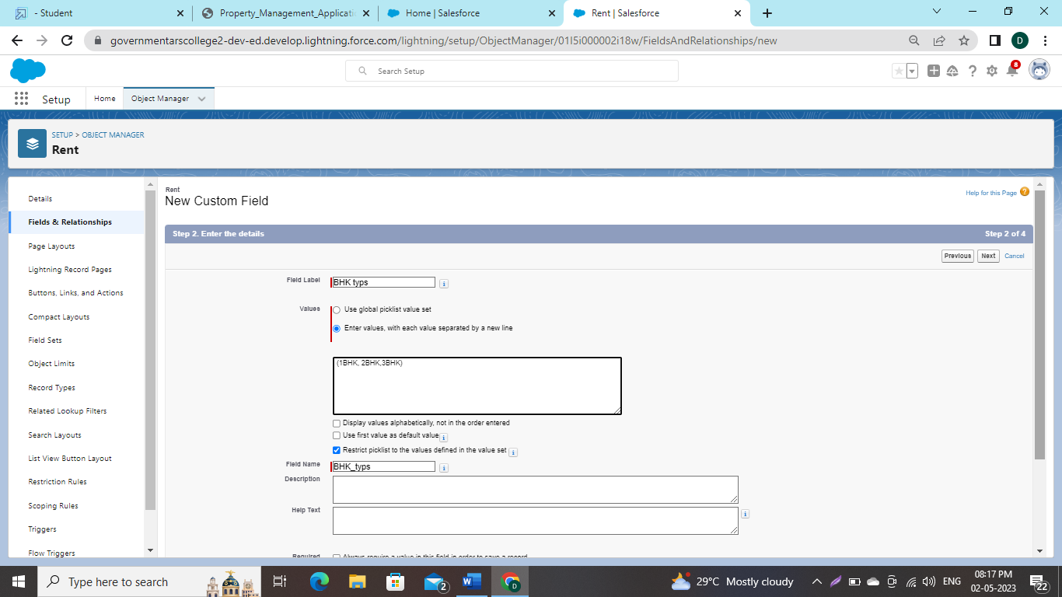

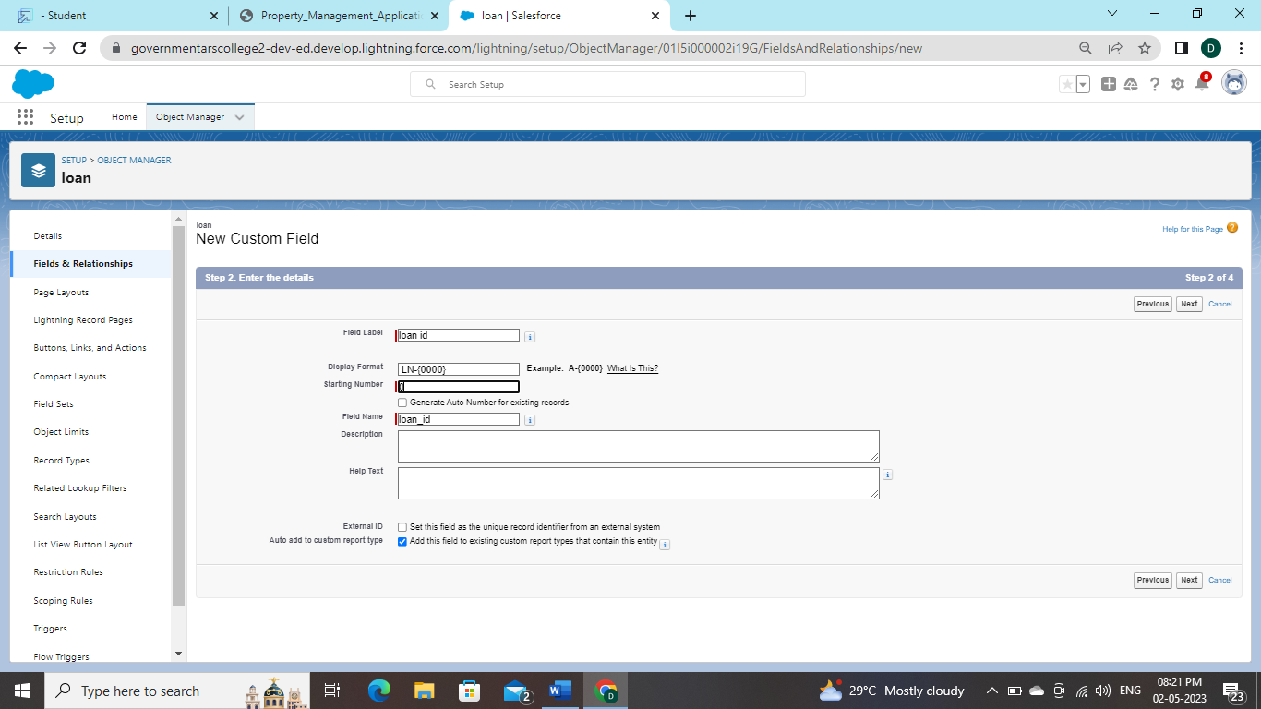

**5. Total Loan Instalments:( Field create the Number as the field data type)**

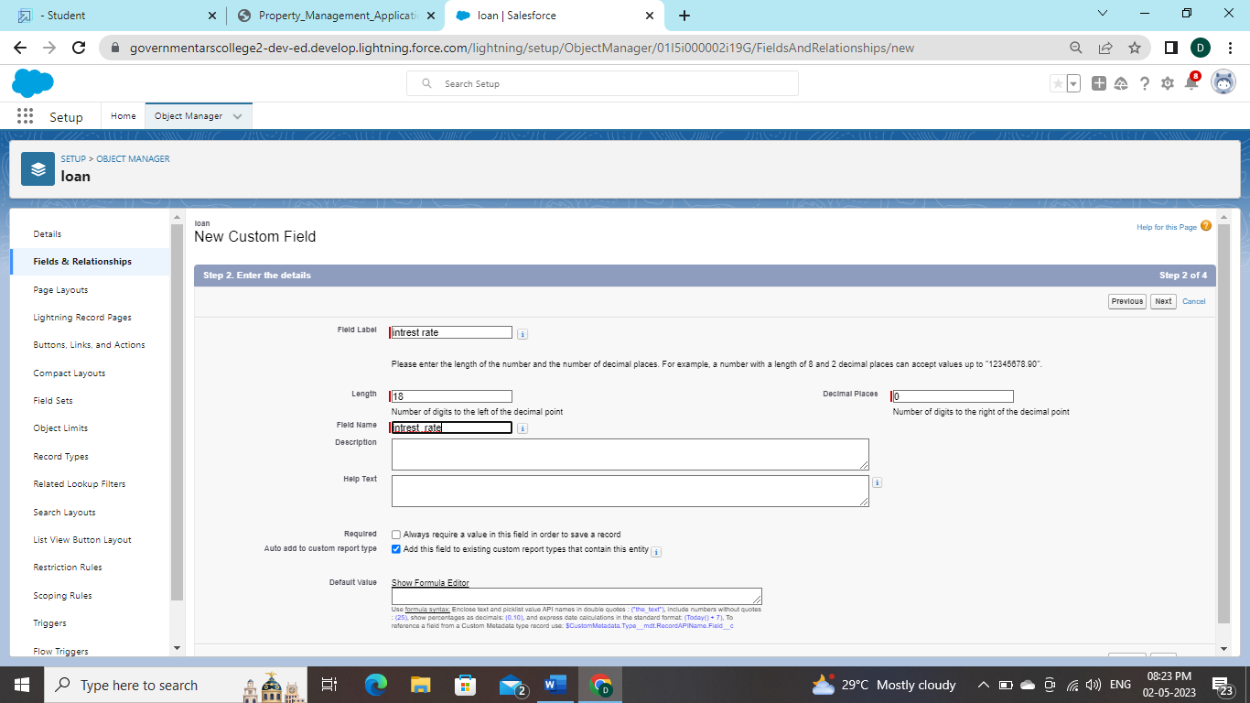

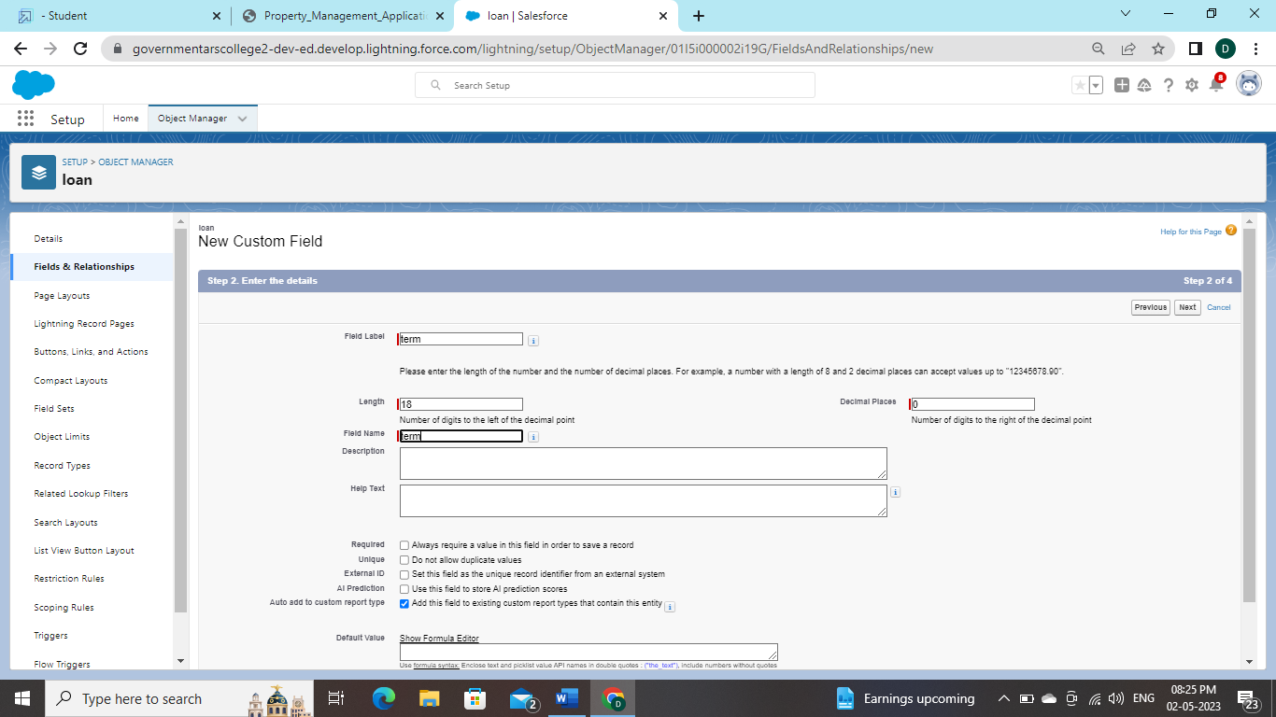**6**

**6.Loan Repayment( Field create the Number as the field data type)**

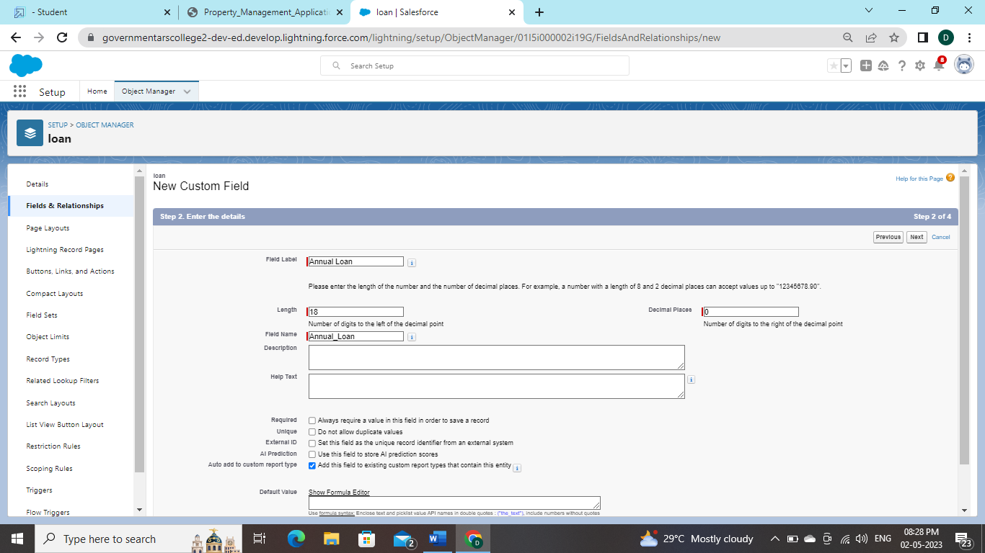

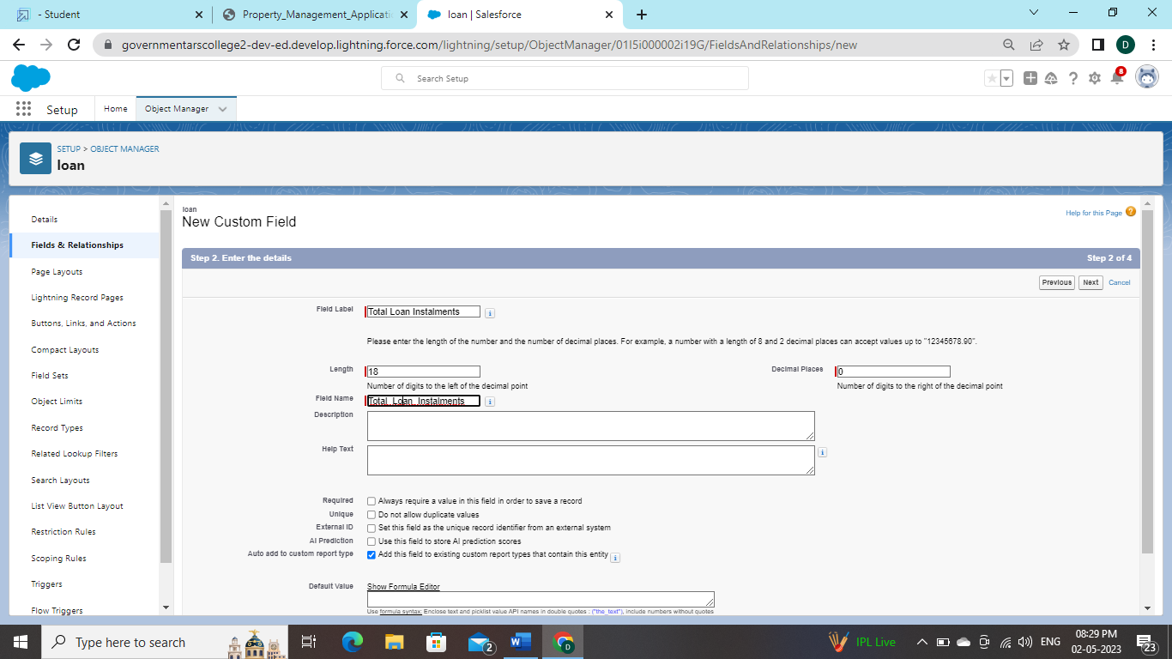

**6. Loan Repayment ( Field create the Number as the field data type)**

**7. Loan Amount ( Select the Field data type as Formula)**

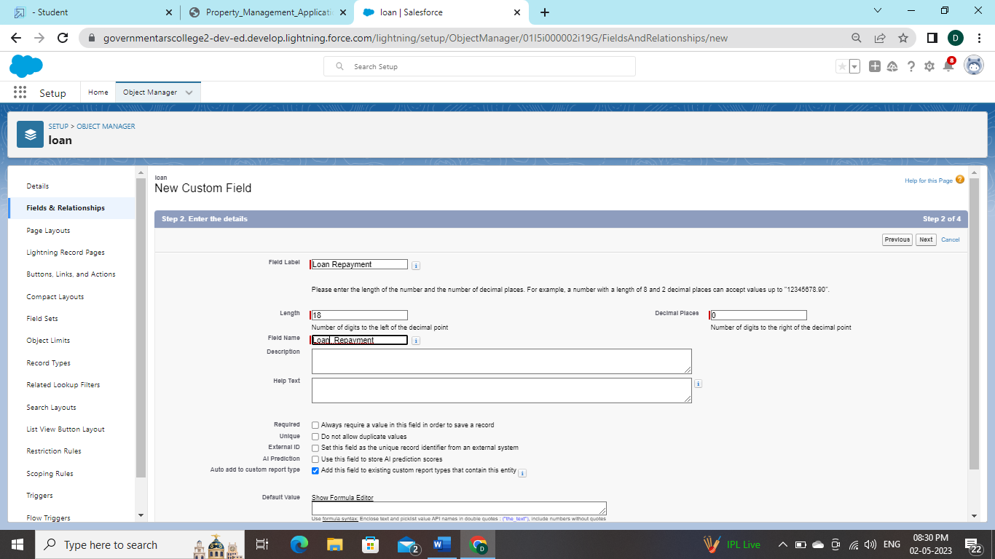

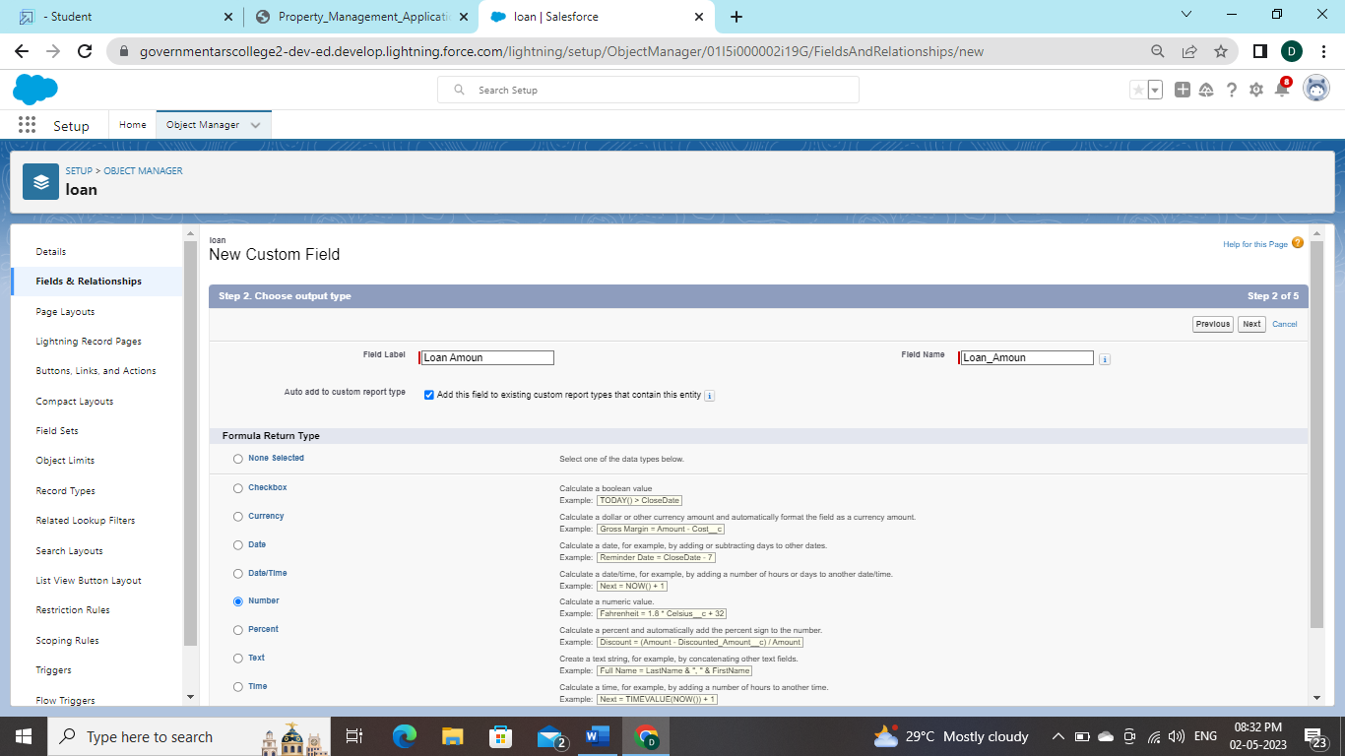

8. **For the Loan Object→ Go to the fields and Relationship and select the formula in field data type.**

**In Formula option select Advanced Formula and write the following formula (Loan_Repayment__c * (((1+( Interest_rate__c /52))^ Term__c) -1))/(( Interest_rate__c /52)*((1+( Interest_rate__c /52))^ Term__c)) ##Check the syntax below whether the formula syntax is correct or not**

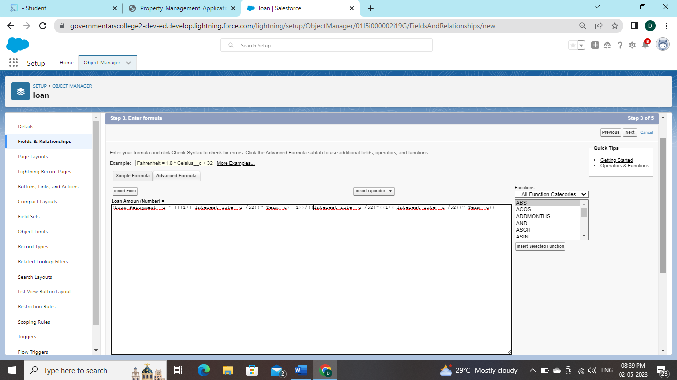

**Activity 1:**

**To create a new profile:**

1. **Go to setup → type profiles in quick find box → click on profiles → clone the desired profile (standard user is preferable) → enter profile name → save**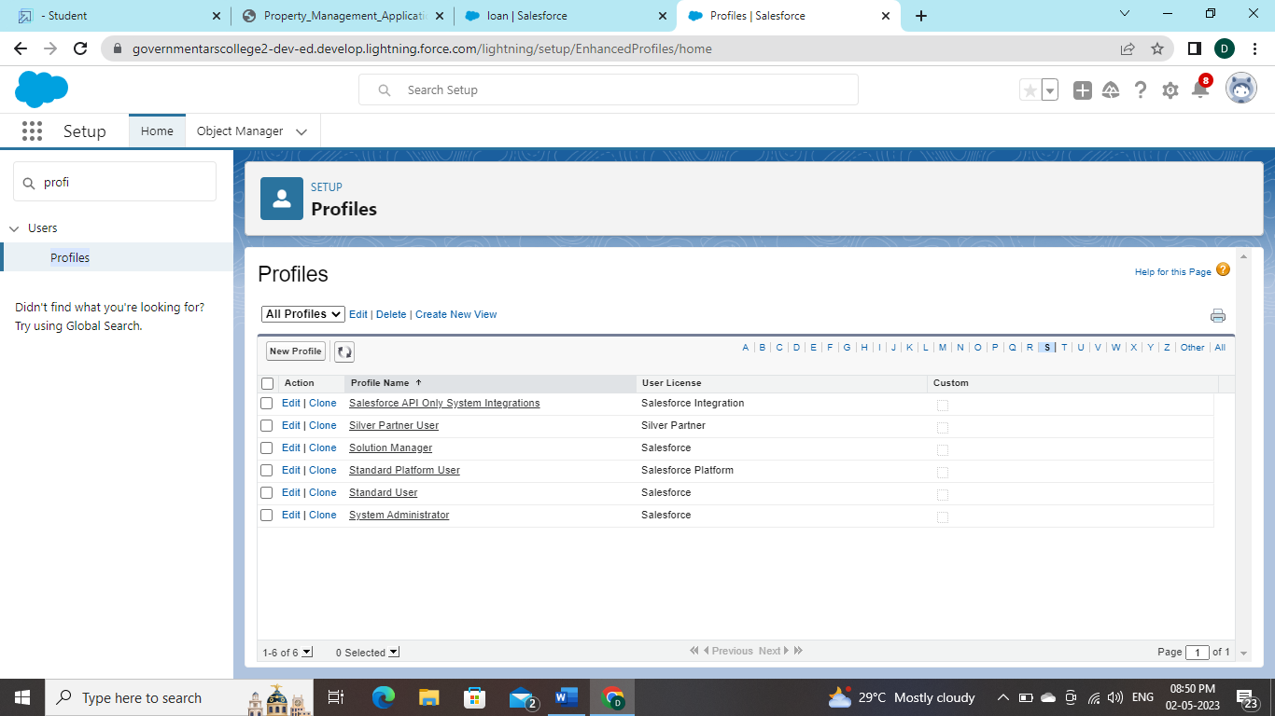

**2. .Enter a Profile Name**

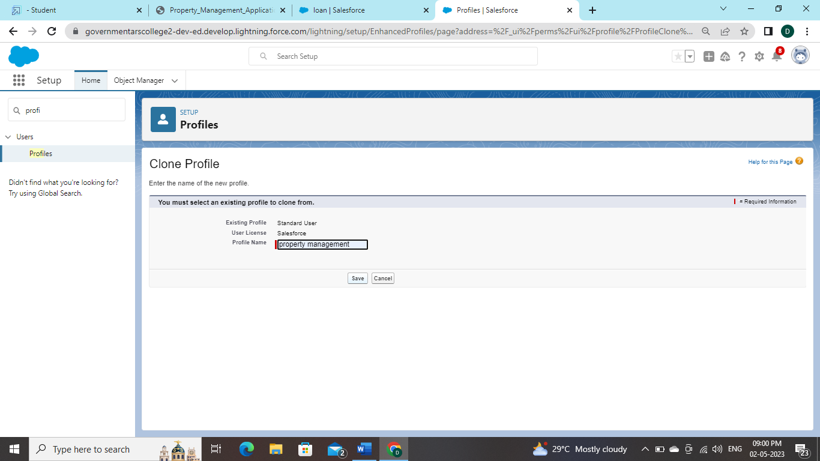

1. **Click on the new created profile**

**4. While still on the profile page, then click Edit**

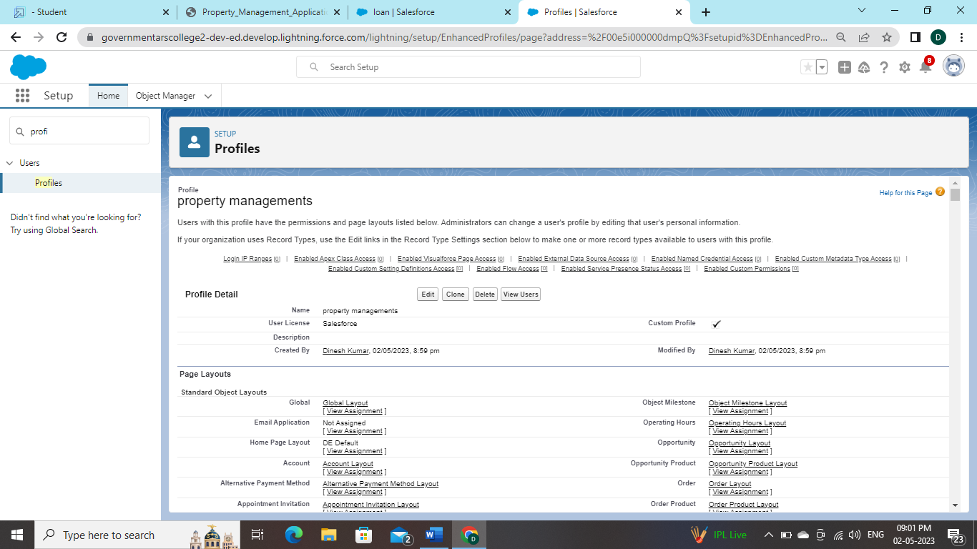

5. **Scroll down to Custom Object Permissions and Give view all access permissions and assign to the parent profile**

**6. Sales Manager →Standard user Profile , Marketing Executive1 and Executive2→Standard Platform User,Marketing Manager→Standard Platform User For**

**1: Create User**

**1. Go to setup → type users in quick find box → select users → click New user.**

**Activity 1: Create User 1. Go to setup → type users in quick find box → select users → click New user**.

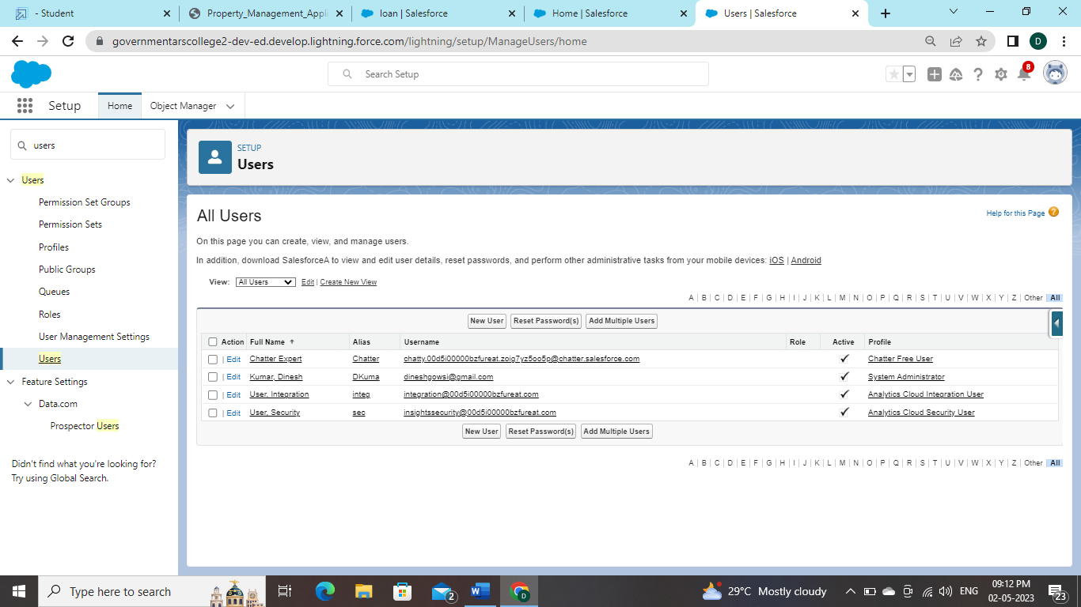

**2. Fill in the fields (first name, last name, alias, email id, username, nick name, role, user license, profiles) → save**.

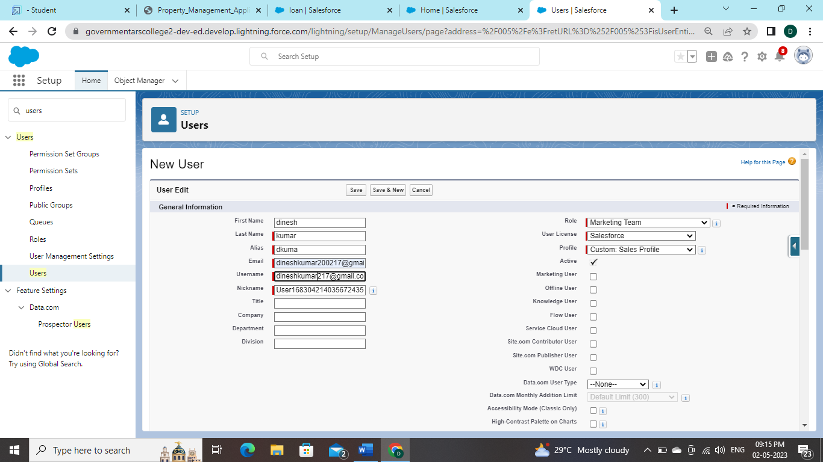

**Activity 1:**

**Create the Permission Sets**

**1. Go to setup → type “permission sets” in quick search → select permission sets → New**

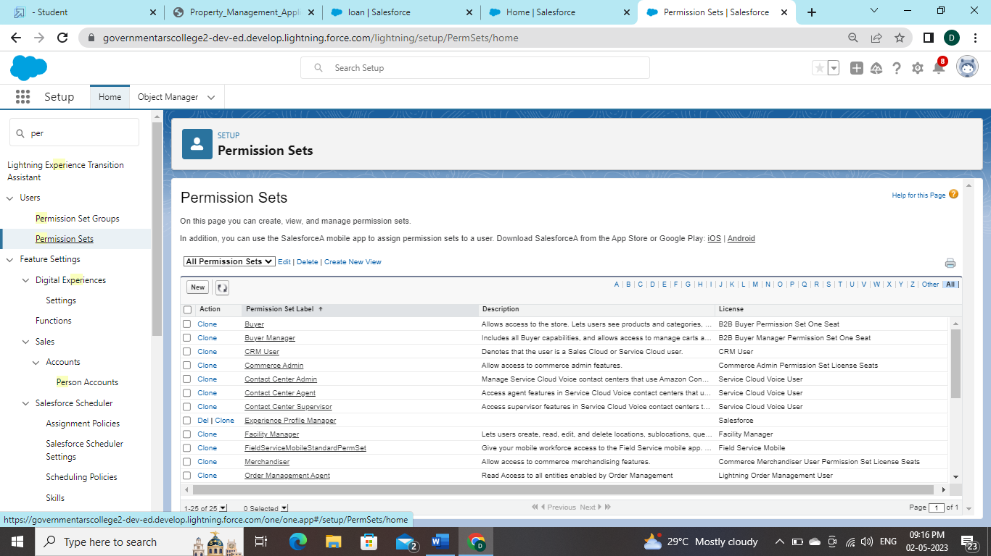

**2. Enter the label name → save**

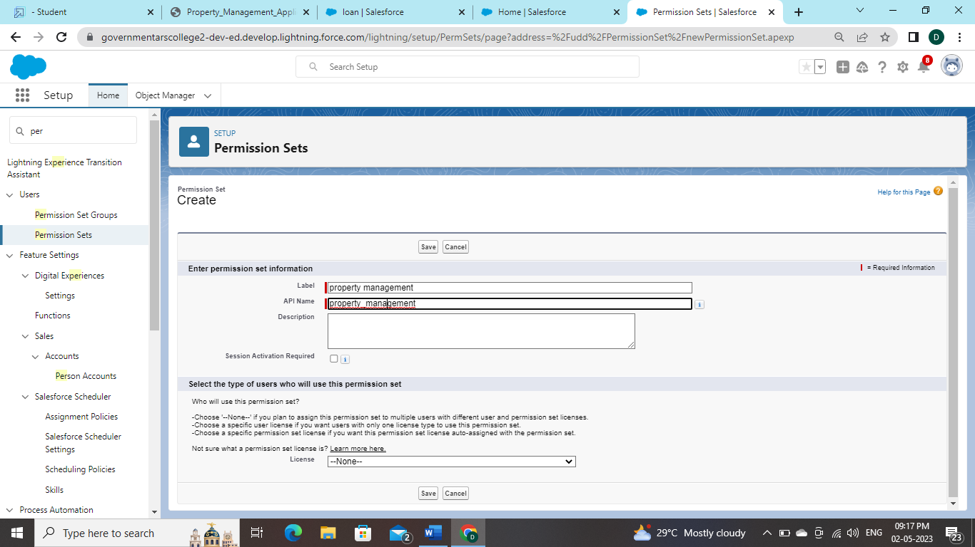

**3. After saving the permission click on the Manage assignment**

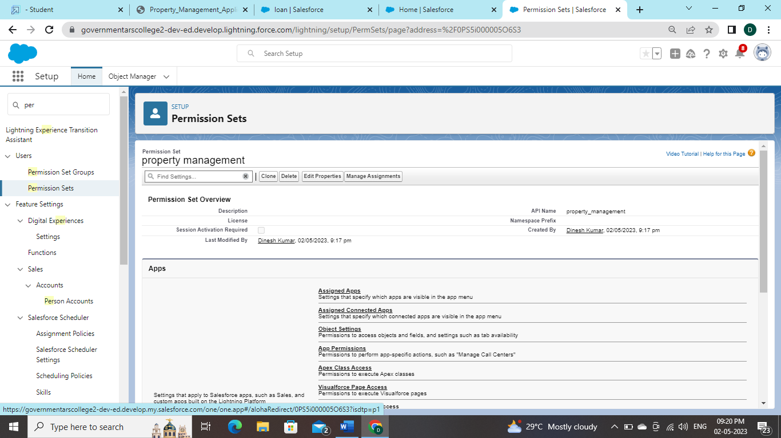

**4. Now click on the Add Assignment**

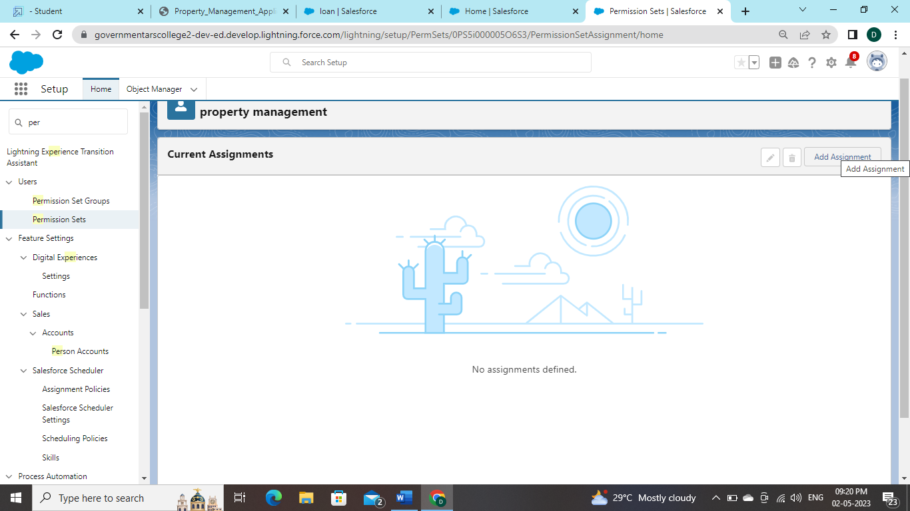

**Activity1:**

**Create OWD Setting**

**1. Setup, use the Quick Find box to find Sharing Settings.**

**2. Click Edit in the Organization-Wide Defaults area.**

**3. For each object, select the default access you want to give everyone.**

**4. To disable automatic access using your hierarchies, deselect Grant Access Using Hierarchies for Lead, Rent custom object** 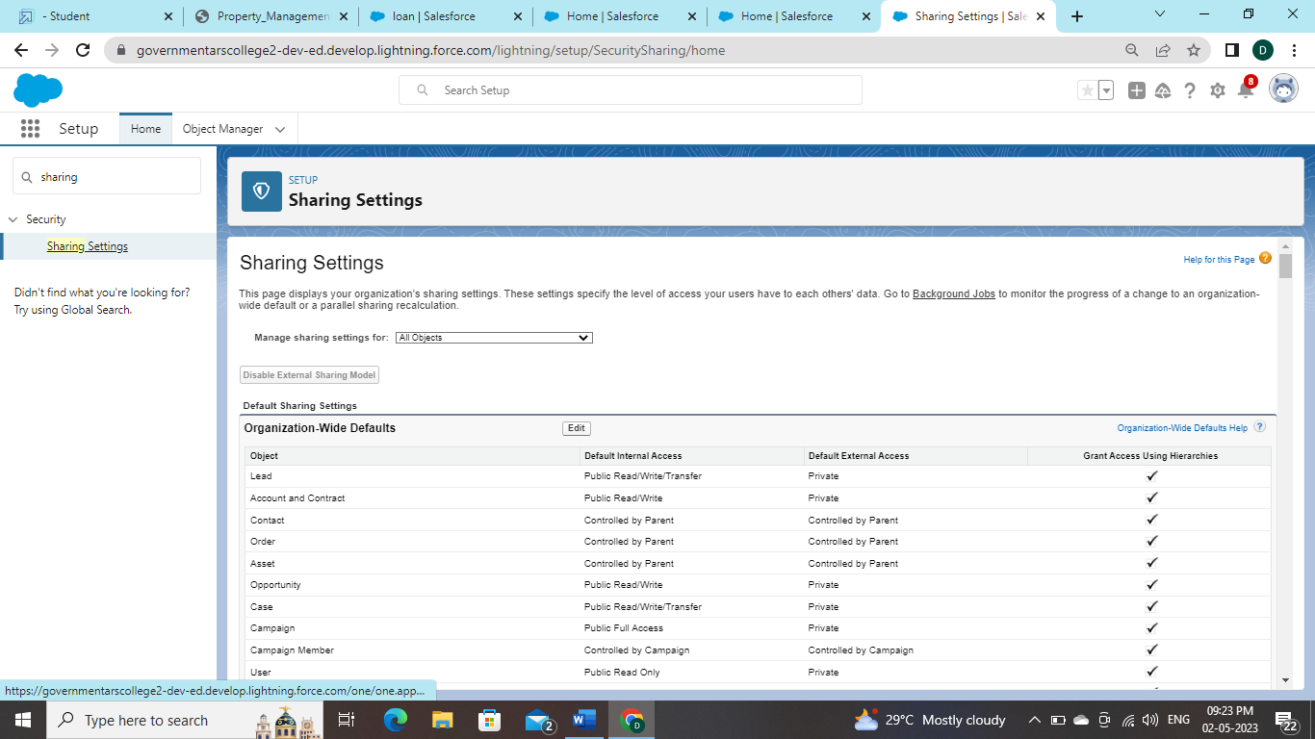

**5. Click Edit and from the Drop Down select private for internal and external**

**6. This Setting is for all the User Which have been Created**

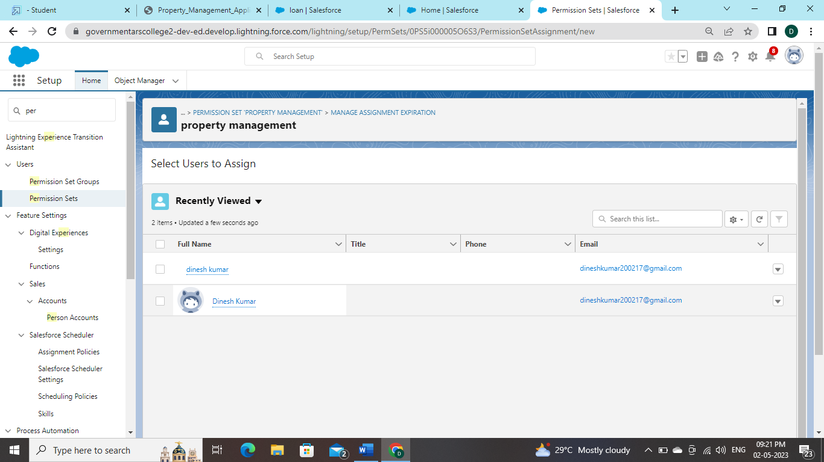

**Activity 1:**

**Create Report**

**1. Go to the app → click on the reports tab**

**2. Click New Report**

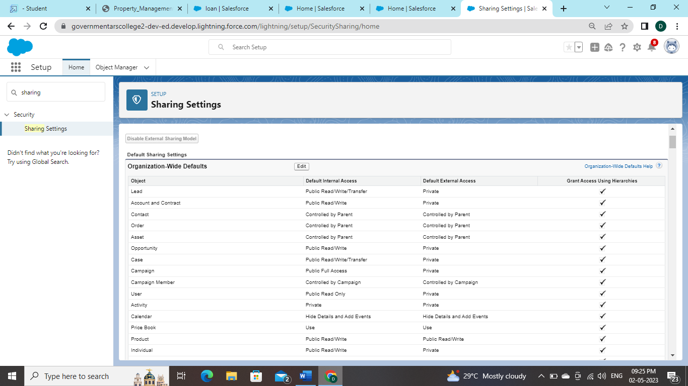

3. Select report type from category or from report type panel or from search panel → click on start report.

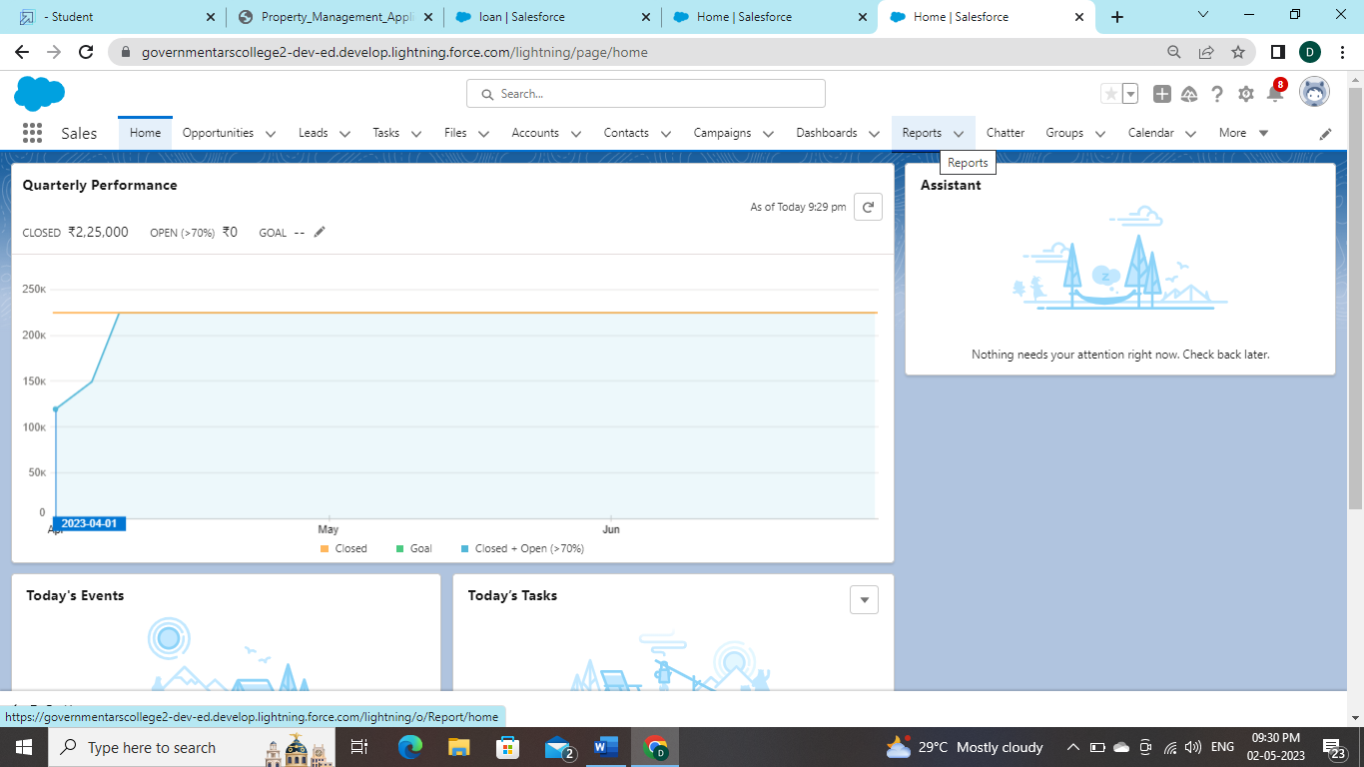

**Activity 1: Create Report1. Go to the app → click on the reports tab**

**2. Click New Report**

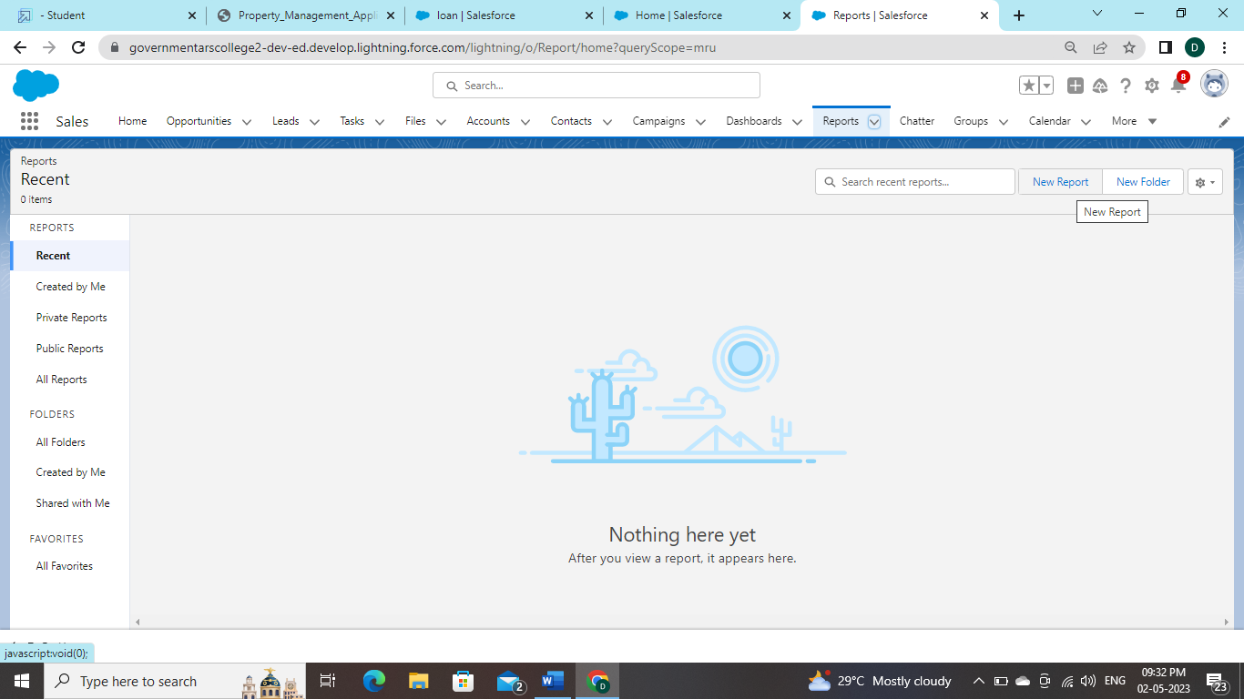

**3. Select report type from category or from report type panel or from search panel → click on start report.**

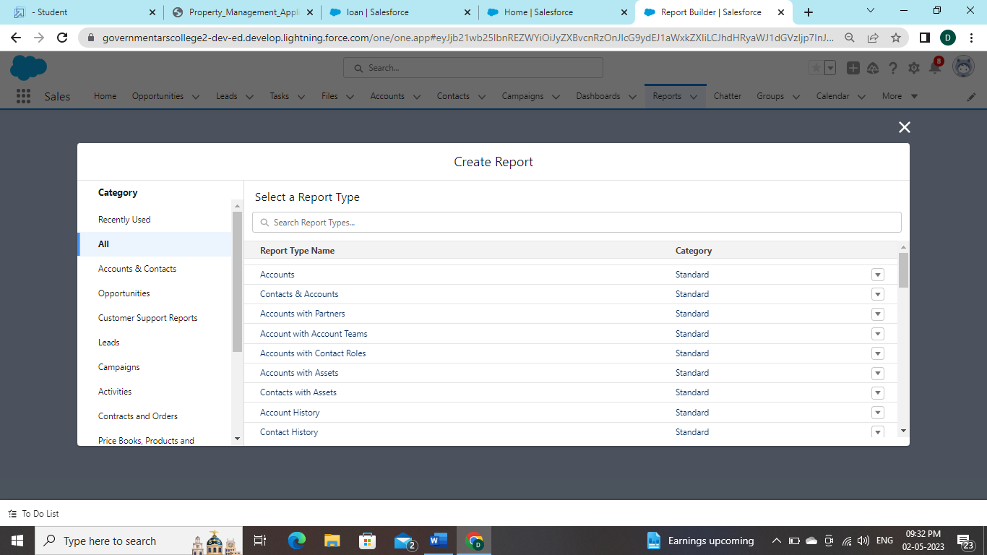

**4. Customize your report, then save or run it.**

**Activity1:**

**Create dashboards**

1. **Go to the App Launcher and select the Dashboards**

**2. Select add component**

1. **Select the folder select the following option new lead with loan Amount**

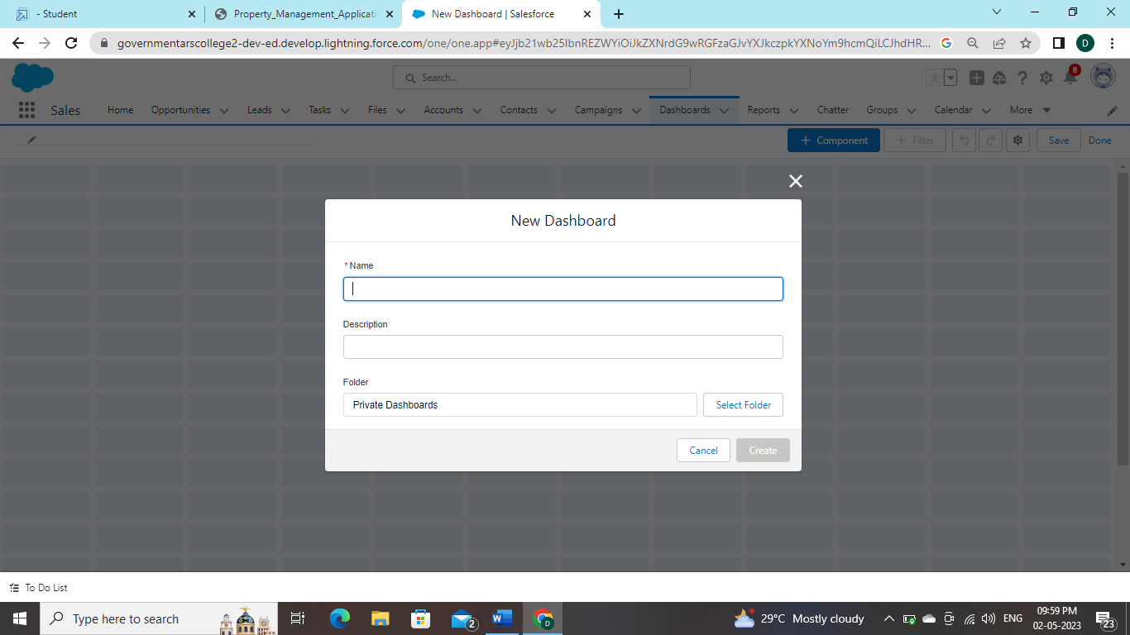

**4. Select in which format you want display chart**

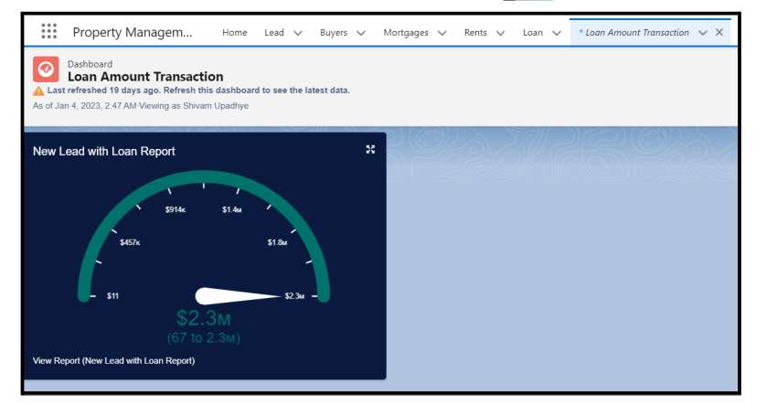

**TRAILHEAD PROFILE PUBLIC URL**

**Team leader - Dinesh Kumar S - https://trailblazer.me/id/dkumar2087**

**Team Member1 - Dinesh L - https://trailblazer.me/id/sdinesh60**

**Team Member2 - Gomathi M - https://trailblazer.me/id/gomam9**

**Team Member 3 - Dharshini V - https://trailblazer.me/id/dvelusamy2**

**ADVANTAGES AND DISADVANTAGES:**

### **ADAVNTAGES:**

### **1. Having Quality Tenants**

### **2. Avoid Costly Lawsuits and Liabilities**

### **3. Higher Tenant Retention Rate**

### **4. On-Time Rent Payments**

### **5. Competitive Rental Rates**

### **6. Lower Maintenance Costs**

### **7. Increased Efficiency and Savings**

**DISADVANTAGES:**

* **Loss of control: If you are the kind of property owner who wants to have total**

**control over every aspect of your business, hiring a property manager is**

**certainly not the best call for you. ...**

* **Expense: For the budget conscious property owner, hiring a property manager**

**may feel like an unnecessary expense.**

**CONCLUSION:**

**management requires people from all different backgrounds to work as ahigh performing team. As the owner of the firm and senior leader, I must be committed to diversity by removing my bias about young women and men. Now that I am aware and acknowledge my bias, I can develop a strategic plan that aligns with the firm’s goals. Social media can encourage prejudice therefore it should not be the primary source of identifying data.**

**FUTURE SCOPE:** **The growth in services means we might see more specific**

**property management firms. Firms specifically for single-family residential units.**

**THANK YOU !**